**Table of Contents**

Start-Up Decisions 2 – 7

Quarter 1 Operations Log 8 – 14

Special Decision – Security Devices 15 – 17

Quarter 1 Financial Logs 18 – 21

Quarter 2 Operations Log 22 – 25

Special Decision – Ethics 26 – 28

Quarter 2 Financial Logs 29 – 32

Quarter 3 Operations Log 33 – 37

Special Decision – Pushy Employee 38 – 40

Quarter 3 Financial Logs 41 – 44

Quarter 4 Operations Log 45 – 48

Special Decision – Bait and Switch 49 – 51

Quarter 4 Financial Logs 52 – 55

Quarter 5 Operations Log 56 – 60

Special Decision – Purchasing Policy 61 – 63

Quarter 5 Financial Logs 64 – 67

Quarter 6 Operations Log 68 – 72

Special Decision – Pushy Employee 73 – 74

Quarter 6 Financial Logs 75 – 78

Quarter 7 Operations Log 79 – 81

Special Decision – Cooperative Advertising 82 – 84

Quarter 7 Financial Logs 85 – 88

Quarter 8 Operations Log 89 – 91

Quarter 8 Financial Logs 92 – 96

Works Cited 97 – 105

**Start Up Decisions**

**Background**

To begin with, the previous owners had this establishment located by a college campus. The building itself is 1,500 square feet with $5,000 due for rent quarterly. They (the previous owners) stated they experienced moderate success while running in this location. The products sold were casual lines of clothing with low prices, considering the main market is the students from the college. While this location experiences a significant amount of foot traffic from the campus, parking is limited and during certain times of the day could be hard to reach, considering class releases and students leaving who do not live on campus.

They experienced moderate success with selling causal clothes. The previous owners reported making $100,000 the previous year and only half of that was used to pay expenses, so they managed to garner a good profit. The staffing level was a bit low, with a full-time manager and salesperson carrying over to the new business. With the business near the college, the advertising was mainly focused there. Prices were also kept with that demographic in mind, college students do enjoy a bargain for everyday clothing.

**Location**

There were three different locations to choose from, either keep the business as the location it was already established at or move it elsewhere. The options given were a shop within a shopping center with free advertising, providing 2,000 square feet with $6,000 in rent per quarter. The other option was a shop on main street that is still developing, with rent still at $6,000 per quarter but providing only 1,800 square feet. The third was the existing building, with $5,000 in rent per quarter and only 1,500 square feet.

According to an article written by the New York times, one of the biggest sectors to be rocked by the pandemic was the Shopping Mall Industry. (Maheshwari) Many, many big-name retailers were reported to pull out of many well-established locations, attempting to save their businesses. This has left many shopping malls either going out of business or finding other avenues to fill empty areas. However, the solution has been found in certain areas. In Onalaska, Wisconsin, a shopping center by the name of Valley View Mall had recently experienced such an event to where the entire mall was foreclosed on and bought by Well Fargo. (Davis) What has happened since is those spaces have become occupied by small businesses, who experience higher traffic by having anchor stores to generate more traffic to their proximity. (Max) Anchor stores defined are the high, big-name stores such as JC Penny and Sears. More customers wanting to visit these locations will also have to walk past the smaller shops to reach the anchor location. So, because of this potential traffic, higher space offered of 2,000 square feet and the offering of free advertising by the Merchants Association, relocating to the Shopping Center for $6,000 in rent quarterly will be selected.

**Product Line**

While the previous owners stated they sold casual clothing, they also stated they experienced moderate success. This in part had to do with the location of the business. Since there was an opportunity to open in the shopping mall and that is what was selected, the clothing of the business should match the type of shop that the new owner would prefer to have. The new owner is looking at higher end brands that provide more profits but also keep in with the mainstream trends to always stay relatable during the year. That choice lies in whether to choose designer versus ultra trendy. The overall goal of the business is to widen the market more to appeal to a wider audience than just the students that frequent the college campus. According to an article written by Mike Chua designer clothes have more durability and offer more in sizes. (Chua) Designer clothes are normally trendy and the bigger name fashion brands are the ones that set the trends. Speaking of trends, there are two types of trends that occur in the fashion industry. According to Thalia Barrera of tech fashionista “A micro-fashion trend’s cycle typically lasts 3-5 years, but macro-trends often last 5-10 years.” (Barrera) The issue with the Ultra Trendy selection then, is the unknown if the trends followed are going to be the micro or macro, so for now the clothing line selected will be Designer but will be looking closely at sales to see if switch to Ultra Trend is possible.

**Business Name**

The previous owners did not disclose the previous name of the business, but no matter. Rebranding the business breathes new life into it and renews public attention. According to an article written by Dan Fries regarding rebranding “When done correctly, rebranding can differentiate you from your competitors, open you up to new customers, increase profits, strengthen customer loyalty and enhance brand awareness.” (Fries) While there is a previously established business that was well known at this old location, considering there is going to be a move to a new location with new management, retaining the old name would not be optimal for the new business model.

The name of the new business came quite easily. The last name of the new owner is Rowan and according to the Social Security Administration, the name Rowan has grown considerably in the past twenty years and the name means protection. (Mama) Coupled with the definition of a small store selling fashionable clothes, Rowan’s Boutique should be a perfect name for a designer goods store, considering that’s the definition of the word Boutique. (Merriam-Webster) It sounds fresh but also upscale. Also, according to Trademark Search Company, using an entire personal name is risky, but it does give it a human touch along with increasing company-customer connection. Considering the product will be higher end clothing, a reputable name people will remember will be paramount.

**Financing**

According to the Small Business Administration, there are several different ways to fund a business. Self-funding, through family or own funds, investors, or loans are the main three ways to get appropriate funding. (SBA) The options provided are a Bank loan of $25,000 with 8% interest and a quarterly automatic deduction of $2,500 for principal reduction. The other option is borrowing from a friend, again at $25,000 with 10% interest, terms require a payment per quarter of interest, but can pay loan principle any time. Finally, there is an angel investor, who will buy 50% of the company’s stock for $25,000. The team would own the other 50% and the number of shares available would be 5,000. The advantage to this is that there is no loan to pay back or interest each quarter, unless additional funds would be needed, then the loan from the bank would be at 12% with an automatic $2,500 loan payment would be imposed.

This is a term called Equity Financing. According to an article written for Investopedia by Caroline Banton, “Companies that elect to raise capital by selling stock to investors must share their profits and consult with these investors when they make decisions that impact the entire company.” (Banton) While the selling of shares in exchange for the loan is incredible lucrative considering there would be no loan in place, the *amount* of the shares being given is the key issue. If that scenario were to be chosen, then that angel investor would essentially own half the business. If something were to happen or an unforeseen expense were to come up, then the loan would still need to be taken out and the interest rate would be higher, two percent may not seem much it’s a lot in finance. Also, according to Banton, if there were to be any changes to be made, like say, the clothing line, then there’s a chance that investor may need to be consulted beforehand and may not allow the change over to the new clothing lines. Also, an investor can pull out of the company or sell off their shares as well, it’s theirs to control. While having the loan from the parent of the stockholders is nice for flexible payments, nonpayment could have negative effects on professional relationships and the interest rate is higher as well.

While all three options are ideal, there is one that has a certain edge. According to a Forbes article, there is a distinct difference between an angel investor and a *venture capitalist*. The venture capitalist is the one that will sit on the boards and interfere directly with the operations of the business. (O’Connell) Since this distinction is made and from the description provided by the simulation, this third option is that of a true angel investor. So, with a loan payment eliminated, if profit is being made, then the option of the angel investor is plausible. While the bank has great offerings, their repayment structures are typically rigidly scheduled and if one were to default on a repayment, the consequences could be severe. The option of the private investor is decent, but the repayment schedule being flexible could be detrimental if missed, there’s always that risk. So, the selection of angel investor will be chosen.

**Quarter: 1 Industry: Retail Company: Rowan’s Boutique**

**Operations**

In this simulation, the previous owners reported they usually prefer to maintain a good 40–45-day stock of inventory. They also stated they were at an average of $100,000 in sales per quarter and that equated to around 2,000 tops and 2,000 pairs of pants. computer the purpose of figuring out the new order for the new business, the average sales per quarter and how much inventory the previous owners sold allows us to compute how much the order of new inventory is going to cost. The cost of goods for Tops and Pants are going to be $20,000 and $30,000 respectively. Put together that equals $50,000, which means the turnover rate of the previous business was at 2, meaning the products sold were profitable at the price that had been previously set. Current inventory sits at 600 tops and 1,000 pants, which is extremely below the normal amount that the business should normally have in its inventory. Considering the first

quarter of the year with a clothing business is slow, too much of an increase in inventory could be detrimental to funds. According to an article published by Samuel Rae for Chron, "holding too much stock is expensive, not only is money tied up that could be used somewhere else, holding surplus may result in unnecessary storage, administrative, financing and insurance costs." (Rae)

Considering the previous amount sold and the unpredictability of the customer base now that the location has been changed along with the inventory type, there is potential for there to be overstock in the first quarter, which will be welcome if so to recover from initial costs and to allow for pricing adjustments. So, the initial order will be to make up to the normal amount to see the initial performance of the business. 1,400 tops will be ordered along with 1,000 pants to bring the inventory of both categories up to 2,000 each.

Next in the list of operations will be the issue of the return policy. According to an article written by Ashley Hauge, "The typical time limit can be anything between 14 and

60 days after purchase, depending on the product type." (Hague) The options given are.

30 days with receipt, 10 days with receipt, 10 days if just the wrong size or defective, or 7 days if defective. Considering the fresh start, the business is going to have, having a firm but fair approach to returns will be optimal until there is a reason to strengthen policy. As for Store hours, the previous of 10 hours are going to be kept. This is because for the first quarter, the new owners will be gauging customer foot traffic and since there isn't previous data to compare from with the new location and products, there could be future alterations. According to an article written by Chuck Leddy, "one needs to have a solid understanding of when target audience likes to shop." (Leddy)

**Pricing**

The previous owners established a healthy medium range of pricing for casual clothes. This pricing was double the cost of the material used to make the product, therefore making profit for the previous owners. A similar concept will be employed; however, things get tricky when it comes to pricing designer brands. One needs to ensure the pricing is fair but also makes enough to cover the cost of having the brands in-house. Since that was the line selected, the issue will now be the appropriate pricing of those new brands.

According to an article written by Marlisa Barbieri, underpricing a designer brand can hurt its reputation and compromise the perceived value of the item. (Barbieri) However, overpricing the brand can also have a similar effect. When it comes to the fashion industry, it’s imperative to have items decently priced. According to Emily Farra in her article written for Vogue magazine "The industry standard for a profit margin is between a 2.2 and 2.5x markup, meaning a dress that cost a designer $100 to produce might be sold to a retailer for $220." (Farra)

So, applying this formula would take the new owner to the price of $22, given the cost of the material is $10 times 2.2 equates 22. The price of the pants will be $32, given that 15 times 2.2 would be $33, the price of $32 would keep the price range in a good medium side. Altering the price slightly will also change the amount that’s needed to break even, allowing inventory to last longer but also create more opportunities for better profits. Slight alteration should increase the profit margin a great deal.

**Marketing**

The previous owners did not disclose how they marketed the business, but inference from the proximity to the college would dictate they advertised heavily on campus and the surrounding neighborhoods. Considering the decision to move locations to the new shopping mall, there will be changes needed to how to market the business to make sure there is enough outreach to the new customer market. The choices provided for the new owner to select to build a marketing strategy from are a website, social media, radio, television, community newspaper, campus newspaper, direct mailing, and flyers. There is another element to the marketing for the new business, as stated earlier, this location also gives the added benefit of free advertising by the Merchants Association. For this there also needs to be an examination of the new target demographic.

According to a survey conducted in 2018 by Statisa, of which received 20,409 respondents, those of a middle to high income spent the most on luxury clothes, but also in this study, all three major income groups consumed luxury clothing amongst other top items such as shoes and consumer electronics. (Statista) So, the target income level will be middle to high income. The average age of the customer will be considered next. In a recent article written by Frank DePino, "Today’s luxury brand target audience is 25 to 44 years old. They comprise 64 percent of this overall audience." (DePino) However, the next audience he goes on to say that should be highly target as well are the 18- to 24-year-old demographics as well. But, as a nice twist to this marketing scheme, the previously mentioned article and another Consumer Trends report conducted by Jungle Scout, it is men that are buying more designer and luxury goods. (Jungle Scout) So we know have several types of demographics forming. College Sally, most likely a college student or a student of some form, from the age of 18 to 24 years old, female, or male, that is heavily online and enjoys designer brands. Parents and workers mainly support the middle to high income needed to purchase goods. We then have Trendy Teresa, aged 25 to 44 years old with a middle to high income who keeps up with the latest fashion. Finally, we have CEO Tom, again 25 to 44 years old with middle to high income who keeps up with latest fashion trends. With these demographics in mind, it now becomes time to decide which channels will reach the target demographics that have been established.

For this, there needs to be a better understanding of how customers shop for their clothing. According to an article written by Alaina Bradenburger, "The past decade has seen a major shift as many customers have migrated from buying in person to shopping online, including at small ecommerce shops. In 2021, online fashion was valued globally at $759.5 billion and is expected to grow to over $1 trillion by 2025." (Bradenburger) This very reason is enough for the new owner to closely examine the options of a strong website in addition to making a strong presence on social media. As for the situation of television and radio, well a Forbes article written by Deep Patel summed up the target markets feeling for these channels stating, "They hate conventional television, but are more in love with video content than ever." (Patel) These channels are not going to be effective for outreach.

So as for the new marketing strategy for Rowan's Boutique, there will be a website for customers to purchase online and ship from. Then there will also be social media presence along with direct mailers that will offer the promotion. According to an article written by Seamus Barton, both flyers and direct mailers will be welcome in the digital age, but direct mailers could be considered more stylish. (Barton) So direct mailers will be sent out, as these will also be cheaper to ship out en` masse. Then there will also be a good decision to use the campus newspaper as well, reaching out to the college students who may want a new place to shop. The website will cost $4,000, social media will cost $3,004, the Campus Newspaper will cost $1,601 and finally the Direct Mailers will cost $3,209, bringing the total advertising budget to around $11,814 in addition to the free advertising provided by the Merchants Association. As for the promotion decision, the displays will be updated. The Boutique will be adopting a No Discount policy. While there are many cost saving reasons to give out discounts, in an article written by Kaleigh Moore, "It trains shoppers to not buy at full price, cheapens the product and attracts bargain shoppers, not those who are willing to just pay the full price." (Moore) These are good reasons and considering the product line chosen is a Designer Brand, it would not be wise to have a promotion that immediately cheapens the product. So instead, the displays will be updated, causing the amount of $1,000 to go to Promotions.

**Staffing**

The Boutique will need employees to assist in sales and customer service. Currently, there is just one manager and one full-time salesperson. There are no part-time staff available and there will need to be a decision regarding the wage that is to be given to the part-time employees. Currently, the wages of the manager and full-time employee are at a total of $15,000 with Payroll taxes costing $1,500 making total compensation around $16,500. Training will become available later.

As for calculating the number of employees needed, typically there is the previous month’s sales to compare the revenue earned per employee. According to

Indeed.com the way to calculate is to divide total revenue by number of employees. (Indeed) Additionally, there are other KPI or Key Performance Indicators that will tell the new owner if the amount hired will be sufficient such as the average attendance of the store, the profit margin, and the retention of the customers walking into the store who wind up buying. According to another article written by Chad Brooks for Business.com, "start noticing an increase in service failures, customer complaints, employee burnout, overtime usage, employee turnover and employees’ inability to meet deadlines as indicators it’s time to hire more employees." (Brooks)

To help with the initial demand that businesses always incur when there is an opening of a new store, and to assist with ensuring employees are not overworked, there will be three part-time employees hired. This will allow for a part-time worker in the morning, afternoon, and rotating weekends. This should effectively help to service all customers who come to visit the location and run operations smoothly for the manager. If sales are unexpectedly high in the first quarter, then additional employees will be brought on. However, in the first quarter of the new business, the initial expenses are going to be a bit high. Wage will be set at $10.00 to be extremely competitive with the federal minimum wage of $7.25 per hour. (Labor) This will bring the total cost of wage compensation to $22,935.

**Finance**

There is no profit to report as well as dividends. There cannot be any repayments because the business currently has not made any money yet. The loan balance is at zero because we took the angel investor option, so no pay back will be selected at this time. However, if an extra loan is needed, then repayment will be examined in the second quarter.

**Special Decision- Security Devices**

As with most businesses, one of the biggest threats to a business’s inventory besides not maintaining enough, is the potential for shoplifting. So, at the National Retailers Association’s annual convention, there were several different booths dedicated to the latest in retail security. There actually has been a bit of an issue with shoplifting with the previous owners and even a break that occurred several years prior. The displays included low-cost fake cameras to just give the impression there is security to full featured alarm systems with real cameras.

In all, seven choices are offered at this convention. While it would be cost effective to go without, it is still extremely risky, so something will need to be picked at this convention. The offerings include a shoplifting system, costing $1,664, Burglar alarm, costing $1,632, a Fake warning sign for $101, a Fake laser system for $202, large convex mirrors for $808, two fake cameras, costing $204 and two real cameras, costing $816. There is an option to purchase multiple to have a system to help protect the inventory. The shoplifting system consists of having removable tags for the more costly inventory as well.

In an article published for Business.com by Sean Peek, he writes that there are many different features that a business should take into consideration when choosing a security system. “If considering installing a security system for business, understanding the different types of alarm systems, the available features and the benefits they provide, gives the best shot at choosing an affordable, useful system that will benefit the business for years to come.” (Peek) However, this also depends on the type of business as well. Having a small retail store is not going to have the same requirements as a full-fledged production area full of expensive and dangerous equipment. So of course, Peek goes on to write in his article that some of the most common features needed in most businesses include fire and environmental hazard detection, monitoring of any equipment such as the lighting and HVAC system, and monitoring of doors after hours, such as burglar alarms. Some of the benefits of having a great security system is not just keeping the inventory secure, but also helping to make employees feel safer and boosts their productivity.

In another article published for Forbes magazine, Erik Gaston writes regarding how to properly secure a business in a space that can have severe consequences if left unsecured, the website and technology. Gaston writes “Retailers listed the top five places they are allocating new technology spend – four of them are cybersecurity-related.” (Gaston) This means that if able too, another space that needs to be just as secure as brick and mortar store is anything that the business may touch online with anything financially related. This means having data stored incorrectly and having employees trained properly to know which links being emailed to the store are from actual customers and which are phishing emails. This is extremely impacting to small businesses and worth recognizing in addition to normal security systems because these are systems that prevent harm that could bring a business down faster than just running out of inventory.

With all of this said, the choices must be made before the convention is over. With the higher priced inventory in the boutique, the shoplifting system was selected to help prevent shrinkage. In addition, there is still the potential of an after-hours break-in, even in the mall, so having a good burglar alarm will help deter any after-hours criminals. Finally, two real cameras will be installed to help keep an eye on customers while the store is open to help with any accused shoplifting cases as the cameras will record an image every ten seconds. These choices are made to keep the inventory safe but also to keep the employees safe and educated, as being in a place such as the mall can have all walks of life enter the door and no one really knows what can happen in an emergency. As a result of these choices, Rowan’s boutique was covered in the news for the security system, which will also deter any would be shoplifters.

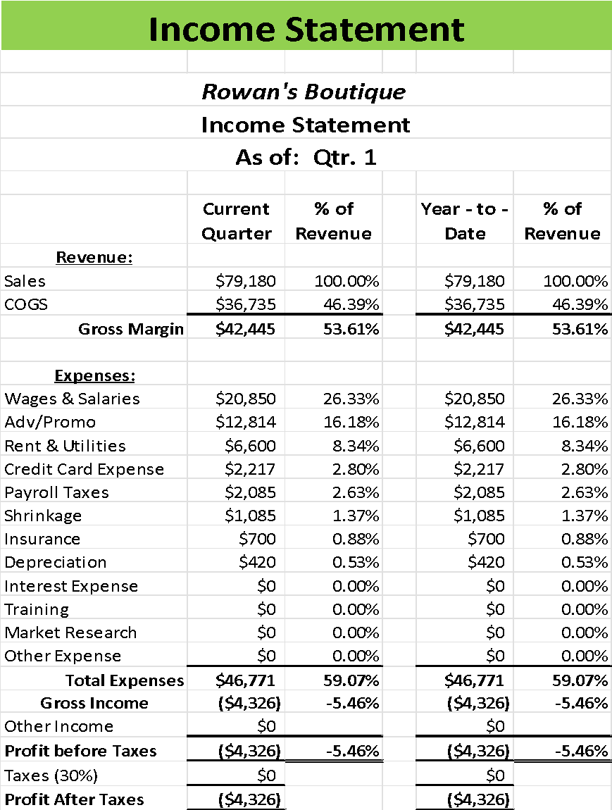

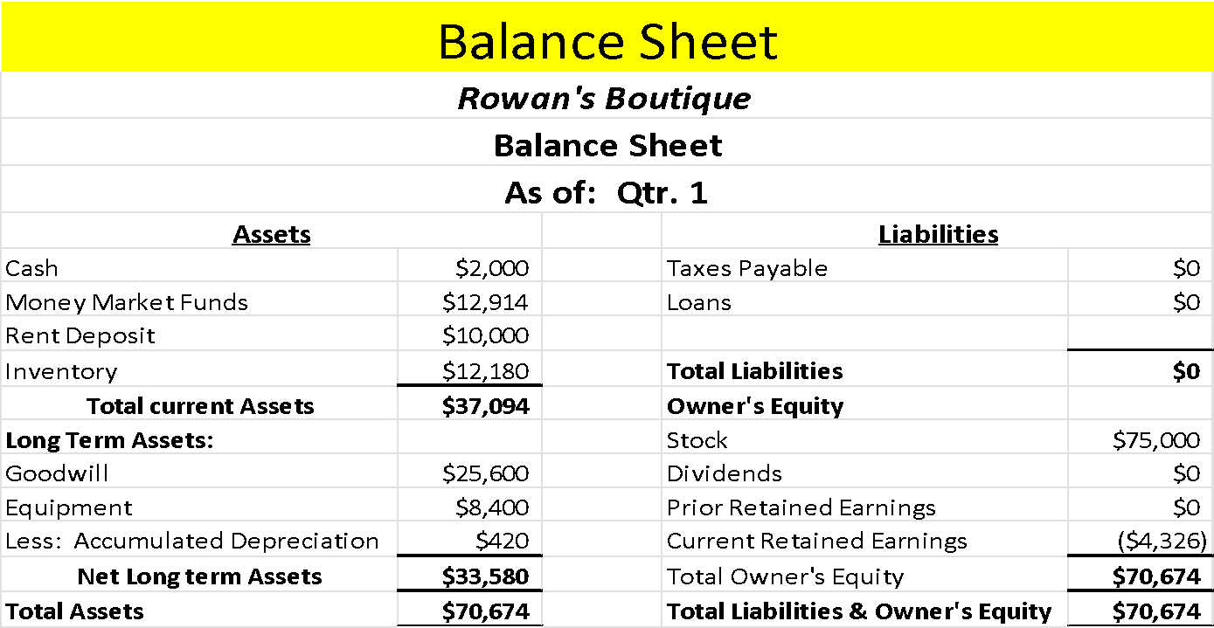

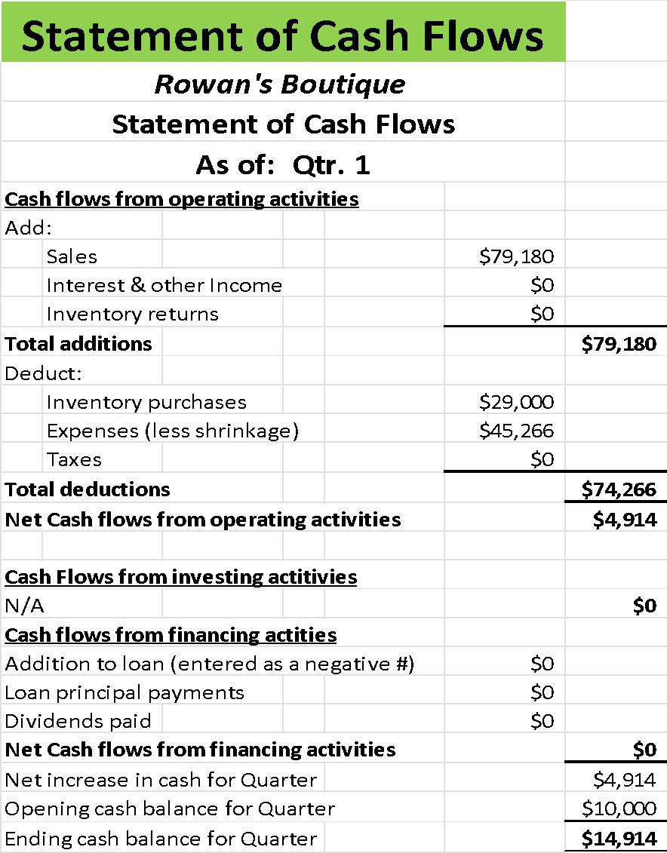

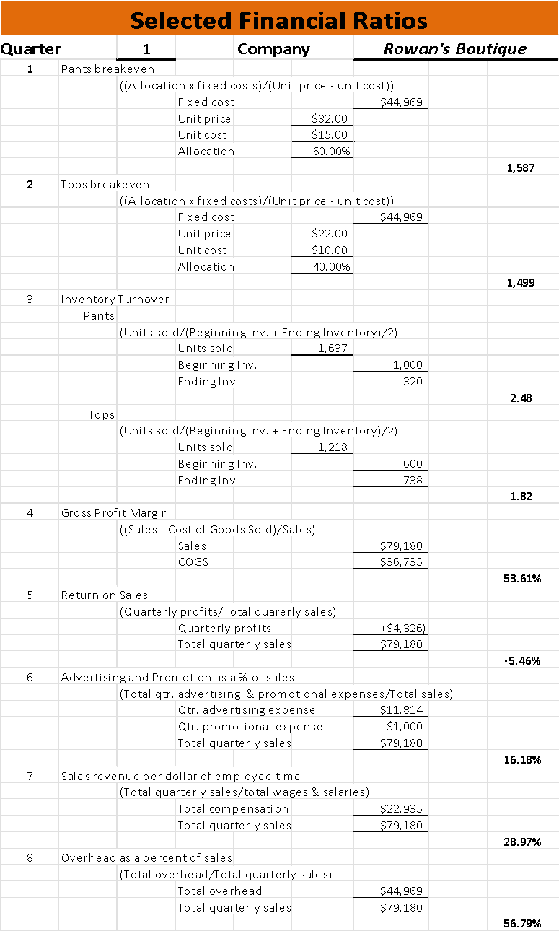

**Quarter: __2____ Industry: Retail Company: Rowan’s Boutique**

**Operations**:

Results from the previous quarter indicated that 1,218 tops were sold, 1,637 pants were sold, leaving the boutique with an inventory of 738 tops and 320 pants. The return policy was set to 30 days with receipt and the store hours were to be open for 10 hours per day. There was anticipation that the following quarter would see an increase in demand. The only issue was that local retail demand in general was low. The decisions were how many more tops and pants to order, the return policy and the store hours set for the quarter.

When it comes to ordering more inventory, there is a minimum stock that must be ordered to keep up with demand. According to an article written by Anna Baluch on behalf of Forbes magazine, “*The minimum stock threshold refers to the least amount of inventory you need in your warehouse at all times*.” (Baluch) In addition to the minimum, the local demand must also be considered when making orders. As for the store hours, the issue is whether to remain at ten, bump up the hours open to twelve, or reduce the number of hours open. According to an article recently published by Allie Gratton with Store force “*Stores continue to see about 50% of their week’s total traffic and total sales in the busiest 20 hours of the week*.” (Gratton) This means that stores really must find those peak times and build the hours off that information.

With this research in mind, the following decisions have been made in regards to the operations for the quarter. With demand expected to rise slightly and to keep with the current demand, the boutique will take advantage of the backstock to order 600 tops and 1,400 bottoms. This will keep up with demand and allow for additional sales. If the demand continues to show little improvement or customer feedback is still unable to find certain clothes, then a switch in clothing lines may be considered for next quarter to Ultra trendy, as discussed in the start up decisions. Second, the return policy will remain for 30 days, as this policy has been fair and there have been no reports of customers attempting to abuse the policy. The store hours will remain at 10 hours but there will be an analysis carried out to dictate the peak times of the day to ensure those hours are being covered.

**Pricing**:

Previously the price was set at $22 for tops and $32 for bottoms, as it costs $10 to make the tops and $15 to make the pants. This makes a profit for the store since the price of materials is covered plus a decent price that most people would be good with paying. With this and the previous research kept in mind, the pricing of the products will not change, as they are bringing in a significant number of sales and are decently marked to match the label. No changes will be made this quarter and the pricing will remain at the current rate.

**Marketing**:

The previous initial selection of marketing was to start a website, be on social media, advertise on the campus newspaper and have direct mailers. In addition, the displays were updated to the latest brand designs. This had a tremendous impact on how well the store did overall, so the marketing strategy will remain the same. So, the next quarter the selections will remain the same. Avoiding the costs of being on television and radio means that the correct audiences are being targeted. Also, there will be research conducted on flyers to see if there is a way to incorporate those into the marketing as well.

**Staffing**:

Rowans boutique took a bit of a hit in staffing in the last quarter. Due to low employment numbers, two employees ended their employment with the boutique due to the workload. In addition, the employees were not given training, which tied into them not wanting to remain with the store. The choices that were offered were to hire more employees, at which wage, and whether the employees should be trained or not. Certainly, there were some very different choices to be made to help keep up with day-to-day demand.

According to an article written by John Hall for Forbes, “*When Gallup reports that over 50% of U.S. employees are “quiet quitting,” failing to reinvest in your current workforce isn’t an option*.” (Hall) This means that not investing in training was a terrible start up decision for the Boutique, but not one that an owner cannot come back from. Another aspect of hiring employees is the hiring process. Although the simulation does not give background on how the boutique does the hiring process, its useful to reflect on that at time when mass hiring could be occurring. In an article about how to hire employees, written by Dana Miranda and Kelly Main, one of their main suggestions was “The best job description in the world is useless if you don’t get it in front of the right people, so be intentional about where you spread the word about the job.” (Miranda) This means that if there was control over the recruiting and hiring of the employees for the boutique, there would be a good way to narrow down choices to employees who would better fit the workplace when hiring for multiple positions.

In this case, the best strategy for Rowan’s boutique will be to employ more employees. To equal out to having two per hour, seven more employees will be hired. This should increase sales and productivity, making the employees feel less overworked. The wage will stay at $10 per hour, as this wage is still competitive in the retail sector. Finally, all staff will be properly trained, so they know how to perform all job tasks with confidence, which should translate into faster sales and happier customers.

**Finance:**

Considering the business was started with an angel investor, there was no loan to be paid back. However, there will be a need in the future to take out a loan, so there will be a need to learn how to allocate money to pay back the interest and money owed to the bank. Needing a loan is not a bad thing, but sooner rather than later will be beneficial for the business. As an article written in Entreprenuer.com states “Taking out a smaller loan and making regular on-time payments will build your business's credit for the future.” (Hecht) So when it comes time for the business to take out a loan, it will be to ensure that it can be paid back along with having a profit. However, no changes till be made this quarter, as there is enough cash flow to cover.

**Special Decision- Ethics**

A school official has approached the boutique with a deal that is too good to be true. He has offered to place the business on the school approved source for the uniforms used by their athletics department for their teams like the cheerleading squad, the band, and their pep club uniforms. The manufacturer can confirm its ability to produce high-quality clothing, but the two-day shipping happens “most of the time”. Shipping costs are covered, and the stock retained if not picked up can be sold to other students. That would lead the boutique to have the profits increased by $3,000 for the coming and if other student organizations were referred, it could see a maximum profit of $5,000. What a deal this is! Until the school official requested that this would be offered upon him being provided with a membership to the local country club, which only costs a meager $500 and other businesses would do the same if they wanted to be ‘friends’ as well if given this opportunity. Oh, well that changes thing a bit, because now this is an entirely different situation.

The decisions given were several different avenues that could be taken. One was giving the school official what they were asking for in exchange for getting this wonderful opportunity that would make the boutique a significant amount of money. The second would be offering them a charge account of $400 instead of the country club membership. The third would be offering the same charge account but for only $200. The fourth would be to turn down the offer and report the official to the authorities. The final was to do nothing and just turn down the official.

According to Cornell Law School, Bribery is “*the offering, giving, soliciting, or receiving of any item of value as a means of influencing the actions of an individual holding a public or legal duty*.” (Cornell) They go on to say that “*Proof of bribery requires demonstrating a “quid pro quo” relationship in which the recipient directly alters behavior in exchange for the gift, “*and*” Another element of proving bribery includes proving intent to influence the discharge of another’s official duties*.”. (Cornell) While this deal is suspicious because it’s too good to be true, the first thing would be to properly assess whether this was a bribe or not. Because to turn down this offer just on gut feeling alone could be a huge hit on the potential earnings for the business, so careful consideration in the next steps is necessary.

To assess whether this school official is asking for a bribe, one must review the situation once more. The school official is asking for a membership at a country club to be gifted to them for them to alter the school approved source list to include the boutique on it to make them the main source for those uniforms. Considering the school official approached the boutique with the offer and ended the offer with how “other businesses would do the same if they wanted to be ‘friends’ as well, alludes to this being offered with the intent of a bribe as well. After assessing, yes, this is a bribe. Which is unfortunate for the school official for two reasons. The first is that, well, bribery is illegal. According to an article written by Ave Mince-Didier and Rebecca Pirius, Attorneys, “*Bribery can be a crime under federal or state law, depending on who and what is involved. Most states have several types of bribery charges, such as bribery of public officials, witnesses, jurors, corporations, and sports officials.”* (Didier-Pirius)

The second reason is not good at all Is because of that first official in the previous definition the public official. A school official, is a public official, according to Law Insiders definition “*School officials means a current Board member; a person certified by the State and appointed by the Board to an administrative or supervisory position*.” (Law) This means that this school official was appointed by either a board or a state and therefore is a public official in addition to a school official. So, this is a very bad crime for so many reasons. One more thing as well, because this is a school official, it also means that they are an educator of some capacity too, which means they are held to a code of ethics by the National Education Association, which states in its code, under Principle 2 “*Shall not accept any gratuity, gift, or favor that might impair or appear to influence professional decisions or action*.” (NEA) Needless to say, bribery in any form is dangerous for all parties included, illegal and can have much more negative consequences. This school official is committing several crimes by offering this bribe and breaking academic codes of ethics to do so.

After all this research, the choice becomes extremely obvious for this situation. Would this deal have made the boutique a considerable amount of money, absolutely. However, the means to which the deal is being made is highly illegal and could negatively on the business if it were revealed to the public about how the deal was made. Not to mention this fits the definition of bribery and if not reported to the authorities, could make the business liable for participating in a crime. So, the decision was made to turn down the school officials but also to report them to the authorities because it sounds like this was something they were comfortable in doing with store owners in the town and it brings students into the situation as well. Taking this deal would break the law, damage the business’ reputation, and help a school official continue to be corrupt.

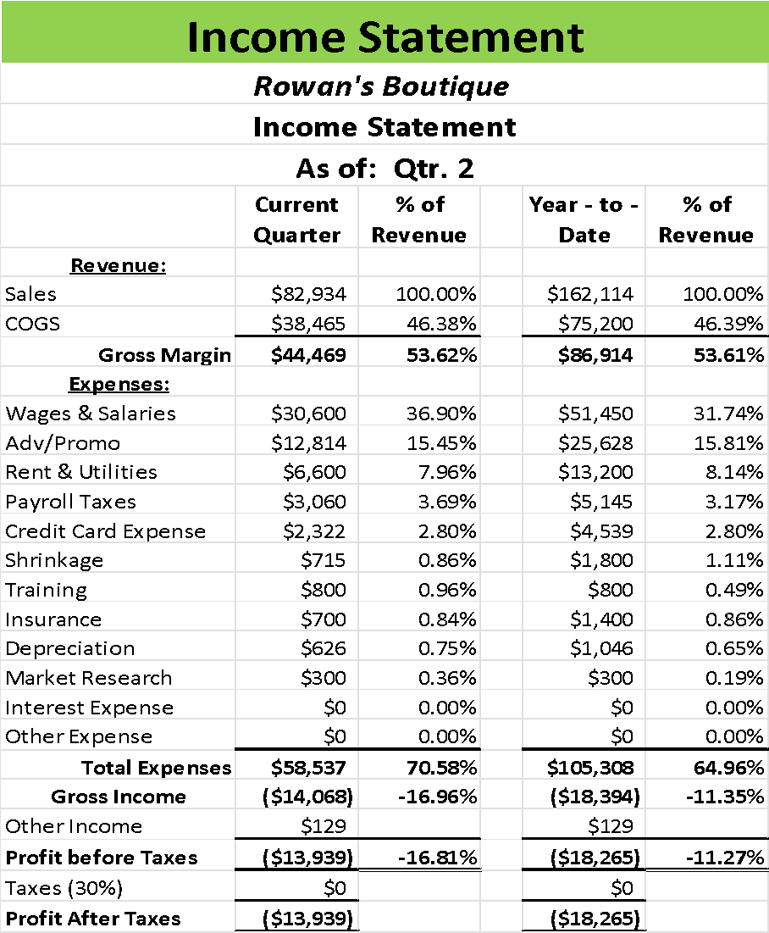

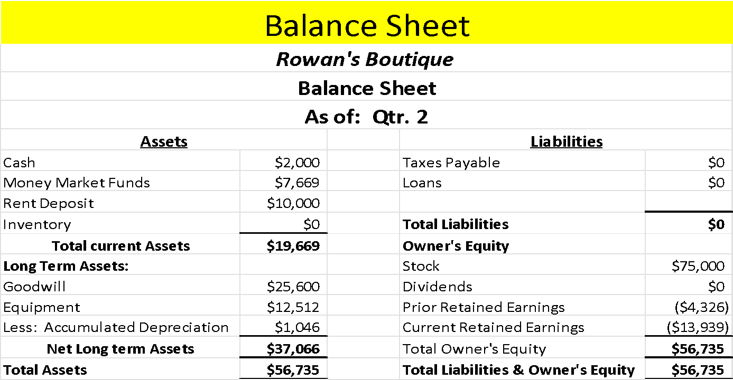

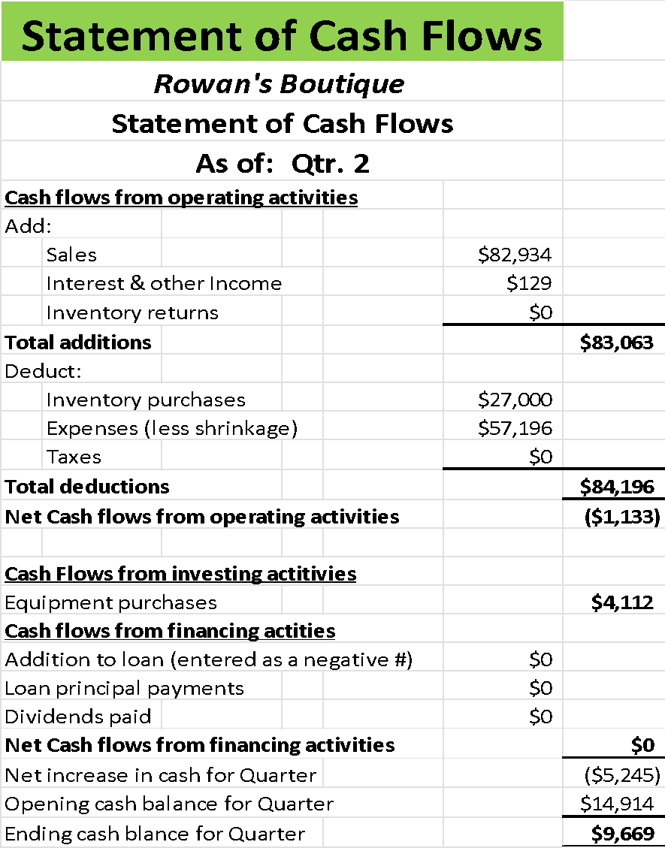

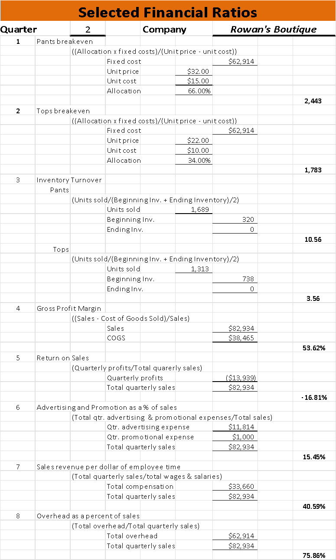

**Quarter: 3 Industry: Retail Company: Rowan’s Boutique**

**Operations**:

An unexpected event has occurred, the inventory previously ordered has run out and now there is nothing in there for the next quarter. In addition, there has been continued feedback from customers regarding being unable to find their favorite brands and the brands they are finding the boutique do not carry the size they require. In addition, demand continues to be lower than expected for the designer brands provided, with only a slight increase projected for the next quarter. The store policy was kept at 30 days with receipt and the store hours would be open ten hours per day.

To keep up with the demand of the local population, listening to the feedback that is being provided is paramount for a small business. According to an article published for Forbes by Jason VandeBoom “*Looking beneath the surface of feedback allows businesses to identify the crux of customers' concerns — the issues that really drive what they say and the scores they give us*.” (Vandeboom) Due to there being repeated feedback about an unavailability of an item they prefer, there is cause to take a pause and assess the current line available. Analyzing why there is feedback is necessary, as understanding that there is a thing in the retail industry known as Fast Fashion, one item that is considered super popular for a certain and just falls off. This causes mass production of these items and has terrible environmental effects. This feedback could be from this type of demand, so altering an entire line for the feedback of a couple customers may not be the best situation. Also, inventory is another issue, as the last order was not enough to last the quarter. According to an article written by Abby Jenkins “To determine beginning inventory cost at the start of an accounting period, add together the previous period’s cost of goods sold with its ending inventory.” (Jenkins) For this, that means that there will need to be a much bigger order to cover and a lot for more demand.

With the previous research in mind, keeping with the designer brand is the right thing to do, as switching could alter who the business appeals to and then it is right back to square one. So, there will be another order, this time much bigger to accommodate current and future demand, so an order of 2,000 tops and 3,000 bottoms will be ordered. This will tie into other decisions that will help to drive up profits to make the business more money and sell more units. The return policy will keep to 30 days with receipt and the business will be open 10 hours a day still to allow customers to be able to visit at their convenience.

**Pricing**:

The pricing was $26 for tops and $36 for bottoms. This made the pricing extremely competitive and appropriate for the clothing type that was being offered by the boutique. This required at least 1,783 tops to be sold for the business to break even and 2,443 to be sold to break even as well. However, due to ordering error, only 1,338 tops and 1,720 bottoms were sold, so the break-even amount was not reached. Part of the issue of the business not making money is in how the clothes are being priced.

According to an article written by Kevin Johnston, “*If you offer specialty lines that your competition does not, you can price according to perceived value.”* (Johnston) So even though there are customers who may be upset at an increase in price, there will be plenty who will see the price and pay it anyways because the boutique is offering special designer brands. According to the sales report conducted regarding the other businesses in the retail market in the same area, Rowan’s boutique is the only one offering designer lines of clothing, so the price does not have to compete with the other stores. Three of the competitors are offering casual lines, and one offering Ultra Trendy clothes. So, the price to be set will reflect the worth of the clothes plus the profit margin needed for the business to break even. In another article written by Samantha Novick, “*Markups are the cornerstone of pricing in the industry. It refers to how much a seller “marks up” a product from its previous cost. In apparel, keystoning is applying a 100% markup—or, in other words, doubling the price*.” (Novick) While there are more formulaic ways to get to a decent price for pricing retail, this is a decidedly easier way to reach the price needed to garner more profit.

So, with the above research in mind, the price of the clothes will be brought up to a better price that will help increase profits but also reduce the number of units that need to be sold to reach the break-even point. The tops will be priced to equal the $14 needed to make times 2 equals $28.00. This will require 1,783 tops to be sold within the next quarter. Customers will notice the change but the brand is worth the price so they should be willing to pay it. In addition, the price jump is only by $6 so the change shouldn’t be too significant. The pants will be priced to $38.00 to account for the fact that the price to make the garment is $19 so times that by two and it arrives at the $38 mark. Adjusting the price to this will also make it so only 1,975 pairs of pants need to be sold, so the order should last if there is an increase in demand.

**Marketing**:

The marketing for this quarter was unchanged from the previous, and it garnered much attention for the business. Accessing the report for the promotions with the surrounding competition, the Boutique is spending the most money on marketing, but it is also translating into the boutique being ahead in sales. The website, social media and campus newspaper are all wonderful channels that have garnered much attention; however, the decision lies within the direct mailers or flyers. It seems redundant to have both, so the decision was to direct mailers. However, mailers are more expensive than fliers so perhaps there could be a little cost adjustment that might reach more potential customers.

First and foremost, there is no research available to give evidence of one being superior to another, both direct mailers and flyers work similarly, and both can garner around the same attention. In the simulation, the direct mailers cost the business around $3,209 whereas the flyers would only cost around $2,002. Flyers are just as powerful marketing tools, as in article written by Jenna Bruce, “Flyers are affordable and have longer shelf life.” (Bruce). According to an article written by PostGrid, a company specializing in helping businesses ship and market affordably, “Direct mail pieces can cost anywhere from $0.30 to more than $10 per person, depending on how much you spend on design, marketing copy, mailing lists, printing, and distribution costs.” (PostGrid) So cost lies in producing the items, of which flyers can be printed designed and printed by the business instead being printed and shipped by another company, so the business can absorb a bit of the marketing cost in that sense.

With the above research in mind, it would then be a more effective strategy to switch from direct mailers to flyers. Not only is this approximately over a thousand dollars less than what it costs for direct mailers, but the design can be more versatile since there is more room for more to be displayed. This would save the business some money and give it a bit more creative freedom. The cost will then alter the marketing budget from around $11,000 to $10,000. The other selections in place will remain; the website, the social media and the campus newspaper will all remain as the selected marketing channels.

**Staffing**:

There have been no other changes regarding staffing this quarter. There has been positive feedback regarding the training and the wages remain competitive in the local area. In addition, the managers and full-time staff are doing well.

**Finance:**

Due to the decision to have an angel investor, there are still no bank loans that need to be prioritized in the budget. Sales are forecasted to increase, so the prospect of needing a loan is diminishing.

**Special Decision: Pushy Employee**

Employees are the backbone of a business. They are the face of the business that customers see, the opinions that the customers hear, and sometimes, customers will come just to see that one employee that just makes their day. Recently, one of the employees at the boutique has been doing a tremendous job. So tremendous that she has a working relationship with some of the manufacturers. It was then devastating to overhear a conversation with a manufacturer and the employee where we learned they are receiving kickbacks in exchange for pushing the sales of a certain line of clothing. Now, as the owner of the business, a difficult decision must be made.

Those decisions include warning the employee, discussing the problem with the employee, firing the employee, do nothing, contact the sales representative regarding the behavior, post a notice to all employees that the behavior is illegal, or finally, warn the employee but also give a bonus of $500 to recognize the job they are doing for the business. There is an issue, however, with enforcement with this employee; there’s a good chance that the employee will quit the business and take their reputation, sales drive, but also their illegal activity, with them. While contacting the representative might do something, it could damage the relationship between the manufacturer and the business. While the employee is doing a terrific job making sales for the company, they are already receiving a bonus to do this, so rewarding them while warning sends a mixed message and could still result in the employee leaving. Firing the employee could cause a ripple effect, as they go to a competitor to work, then those competitors can use the words of the former employee to make the business look even more terrible. We could always discuss the problem face to face, but that would still result in the employee wanting to leave.

Kickbacks are a form of bribery, which is illegal in business. According to a section written by Coxwell and Associates, Attorneys at law, “It involves corruption, however, kickbacks differ from bribes, because they typically involve a pre-negotiated trade of goods and/or services and a quid pro quo style of cooperation.” (Coxwell) This is corruption as well, as these sales are being pushed to make this certain manufacturer more money than the others who supply the boutique. In another article written by Will Kenton for Investopedia, “Kickbacks increase the cost of doing business in countries around the world; they also form the basis for much of the world's government corruption.” (Kenton) This means that accepting kickbacks increases the cost of doing business for all sectors, including the government. Which is why they need to eradicate the acceptance of kickbacks when found.

Here's the issue, it is almost guaranteed that this is not the only employee in the building receiving kickbacks, but not directly mentioned in this environment. If they have their hooks in one employee, they probably have hooks in most of them. Also, it was not mentioned if the employee even knew what they were doing was wrong. So, calling out the individual for accepting the kickbacks will result in a loss of an employee but also a tremendous seller. Doing nothing shows compliance and could result in extremely negative consequences for all. The boutique is also certainly not going to reward the employee for doing something illegal. In this instance, there are two things that must be done, but only one selection can be made. So, the selection to post a notice on the bulletin board was selected. However, in addition to posting on the bulletin board, it would also be beneficial to talk to employees as well. But the reason the bulletin board was selected was for two reasons. One, all the employees are being informed, which allows them to make a conscious decision to either reject or accept the kickbacks when offered, which also covers the business because they are informing all employees, not just the one. So, in the future, if an employee were to be caught accepting kickbacks, the owners can just point to where they posted the notice. Two, the notice doesn’t disappear, and the employee cannot claim they were not told about the policy.

The result of this decision is that there are still some customers complaining about the employee pushing product, so perhaps this employee will need to be let go since there is a lack of adherence to the policy after being informed of the policy. Since the business is expected to have a sharp decrease in sales projections for the next quarter, it may be at that time the business and the employee part ways. It is extremely important though, to understand that even though an employee is participating in an illegal activity, it does not necessarily mean they are knowledgeable that the act is illegal. Once the business has done its due diligence to inform, the responsibility does reside on the employee to adhere to the policy. Also, the other avenue was a mixture of both with a call to the representative as well, but only one could be selected.

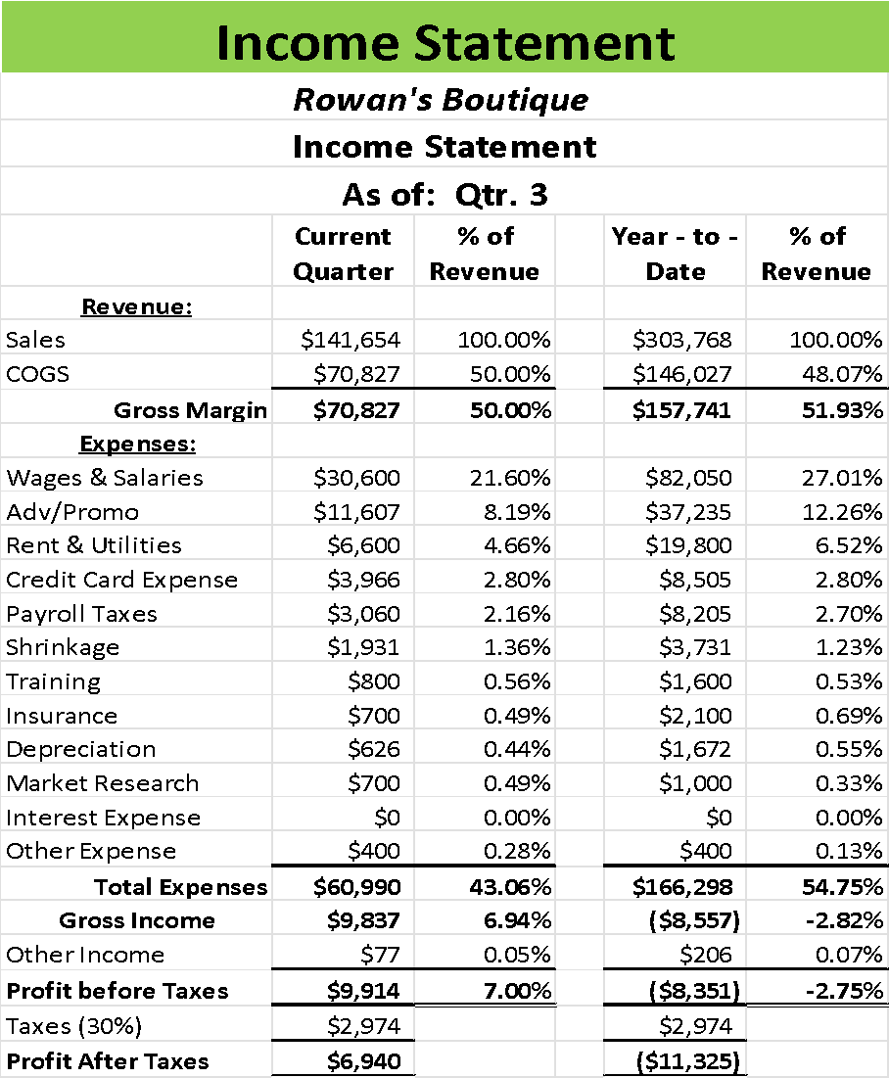

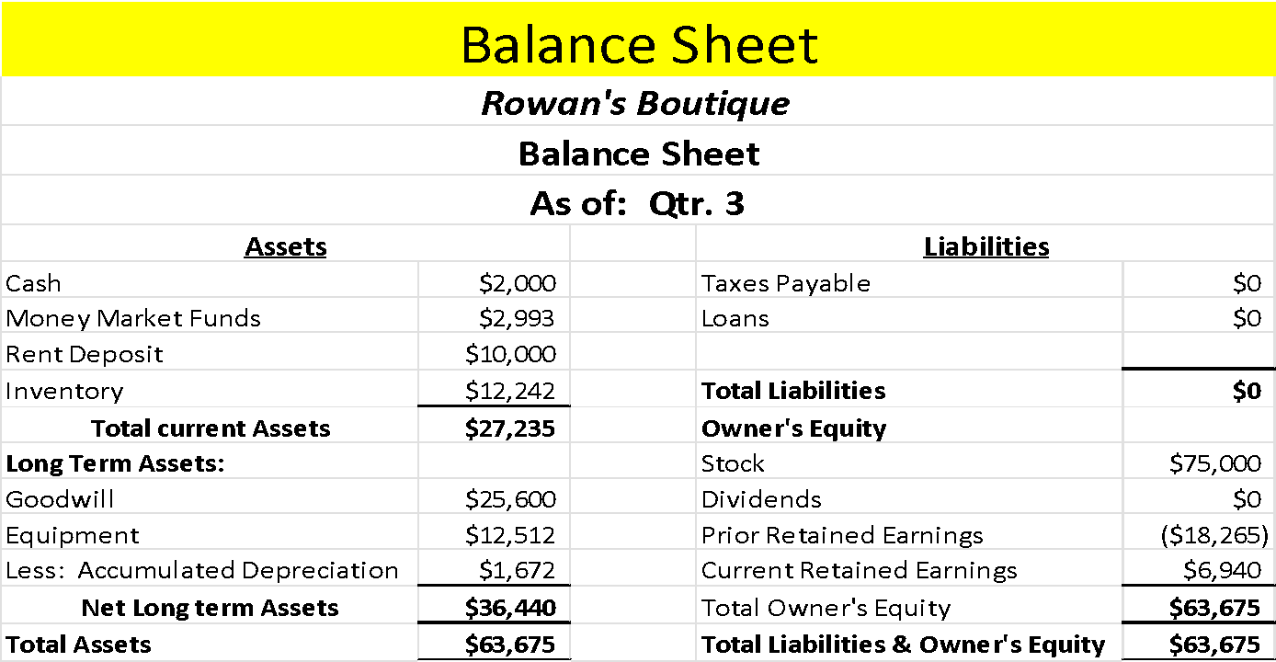

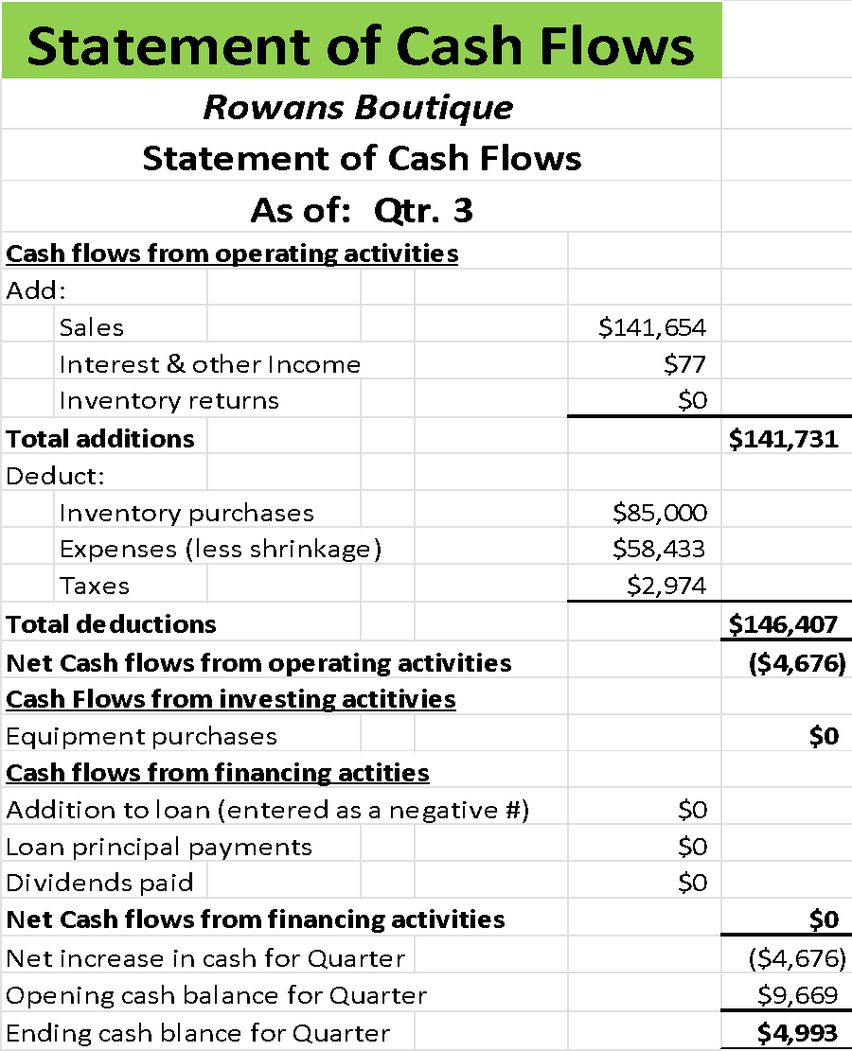

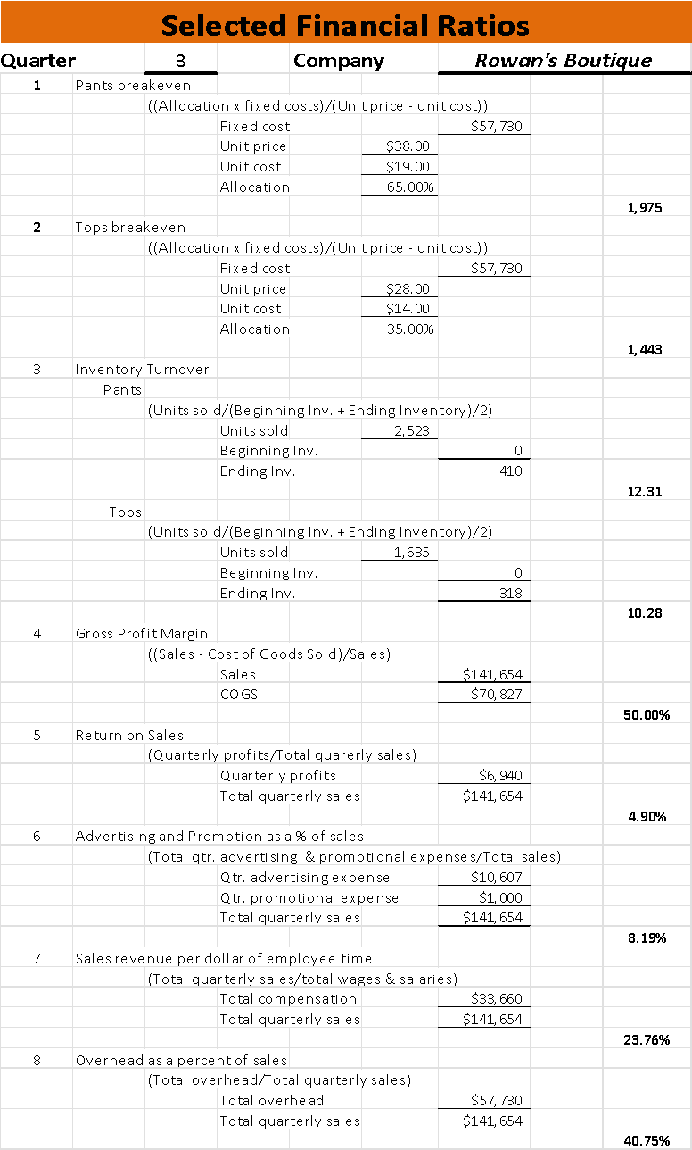

**Quarter: 4 Industry: Retail Company: Rowan’s Boutique**

**Operations**:

The boutique experienced a great quarter with sales. 1,635 tops and 2,523 bottoms were sold, making the total sales earned for the business for the quarter $141,654. This leaves inventory with 318 tops and 410 bottoms. There is a projected increase in demand for the upcoming quarter, so there will need to be an adequate amount ordered. The return policy of 30 days with receipt has been effective, as shrinkage costs are at $1,931.00 for the quarter and are only at an annual total of $3,731.00. The business being open for ten hours per day allows plenty of customers to visit and gives employees ample time to help maintain the cleanliness of the store.

The only decision operationally that will be made is the usual decision to purchase inventory for the quarter. There are several options, order more than the normal order, order less than the previous order, or order the same amount as last quarter. There are also the options to alter the hours the business is open or alter the return policy. Both options are at their optimal level for this business, so keeping the current return policy and ten-hour operational window will continue to contribute to the store’s overall success. The inventory order will be for another 1,800 tops and 2,800 bottoms to accommodate the projected sales and the projected increase in demand this upcoming quarter.

**Pricing**:

Last Quarter, the price had been altered from $22 for tops and $32 for bottoms. This helped the break-even volume be reached with much less inventory, with the excess being profit that can pay for other business expenses. There was initial hesitancy to establish a high price due to the local markets showing the trend was much lower pricing to match the clothing sold. Currently, Rowan’s Boutique remains the only Designer clothes establishment in this area, so the target market is going to only have this shop to visit without having to travel.

Due to these factors, there will not be any changes made to the pricing of the clothing provided, as the pricing allows for a great profit margin and the breakeven volume of both Tops and Pants are below 2,000 units each. So, anything sold over 1,443 tops and 1,975 pants will be pure profit, for the order will have been paid for and now other expenses can be addressed.

**Marketing**:

There is a crucial decision to be made this upcoming quarter regarding the marketing of this business. October through December is the holiday season and sales are expected to be on the rise. While the advertising side the marketing will remain untouched, should Rowan’s boutique offer a limited time coupon to encourage more people to shop here during the holiday season? There are several different options available.

Option one is a simple update to the displays. The other is to offer a 10% sale coupon and update the displays as well. Otherwise, there is the option to do nothing for the holiday season. While normally there is a golden rule to never offer a blanket discount, there is merit in offering a limited time discount, especially when it’s during the holiday season. So, there will be a limited time discount offer of 10% off select items for valued customers to take advantage of.

The reason behind this is because during this season in particular, customers are more likely to spend more when there is a discount of some kind involved. In an article written by Brin Snelling for Forbes Magazine “According to ICSC’s Thanksgiving Weekend survey, 75% of shoppers say they’ll visit a retail shopping center during the five-day holiday.” (Snelling) Another aspect to consider is just how much a shopper is willing to spend during the holiday season, usually looking for designer brands to gift. In an article published by the National Retail Federation “he National Retail Federation today forecast that holiday retail sales during November and December will grow between 6% and 8% over 2021 to between $942.6 billion and $960.4 billion.” (NRF) This means that consumers are always gearing up for this season and are prepared to spend more during this time.

**Staffing**:

The salesclerks are made up of 8 part time workers, one full time salesperson, and a Full time Manager. There will not be more hirings done, as these workers have been able to keep up with the demand. The wage rate of $10.00 per hour remains extremely competitive within the employment market, with only one other retail establishment offering $10.00 per hour. Training will continue during this quarter, as keeping up with training during a hectic time of the year can help keep employees refreshed on policies and procedures during rushes.

**Finance:**

There has not been a loan taken out from a banking institution, so there will not be a repayment that needs to be made. There is an option to pay a dividend to the stock owner. The overall cash available is only $4,993, so a dividend will not be paid out just yet. But if sales exceed expectations during the holiday season as projected, a dividend will be paid out at the end of the next quarter. This is to ensure that there is some cash left over in the business just in case there is an unexpected event next quarter.

**Special Decision- Bait and Switch**

There are many competitors within the local area for Rowan’s Boutique. They provide competition in their prices, most of the time lower than the Boutique’s, and different quality of clothing that may be more affordable to certain consumer markets. However, one competitor has decided to engage in a tactic called “Bait and Switch”, where they advertise a large amount of designer clothing for well below the normal price for high quality, brand name clothing. There have been some complaints about the price due to the competitor’s pricing. The competitor is smart enough to mix with actual designer brands, but the customers have noticed upon entering their business for these “designer” clothes are just normal and are of normal quality. Retailers consider “bait and switch” to be a customary business practice and the pressure from the competitors pricing is starting to hurt business somewhat.

Several different decisions that could be made in this scenario, since there has been some customer feedback regarding the prices, they would have to pay at the boutique compared to the competitor. One decision is to try out the same tactic and see if the customers will give feedback regarding the price, do the same as the competitor and conduct the same type of supposed sale once or twice a week. The business could also up the ante by conducting an ongoing “sale” of this kind with a permanent table in a prominent place in the store. There are also options for rejecting this practice and reporting the competitor to the city’s Bureau of Illegal Practices. Also, there’s the option to go a step further and reject the practice but also to attempt to get the competitor rejected from the Retail Clothing Merchants Association. There is the other option of rejecting the practice but also run an ad to point out the competitors’ actions and how they are wrong. As always, there is an option to do nothing and just not follow what the competition is doing.

According to an article written by Adam Hayes for Investopedia, “*The "bait" in a bait and switch can be an advertised physical product or service that has a notably attractive price or terms*,” and “*Once a customer comes into the store or office to inquire about the advertised price or rate, the advertiser will attempt to sell the customer a more expensive product, which constitutes the "switch*." (Hayes) So this tactic is providing customers with false expectations about what to expect when entering the competitor’s establishment. While the tactic is certainly bringing customers in the door, it’s almost certain a good number of them leave without purchasing because the expectations were not met up to. So, this tactic negatively impacts the customer experience. This is also impacting Rowan’s Boutique, as there have been customers visiting the business that were expecting similar pricing but disappointed that the prices were higher than expected.

In another article regarding the tactic, Cornell Law School states that “*Bait and switch advertising is grounds for an action of common-law fraud, unjust enrichment, and sometimes breach of contract. A “bait and switch” is also a violation of the Consumer Fraud and Deceptive Business Practices Act.”* (Law) So, not only is this action being taken by the competitor ruining their customers’ experience, but the act is also illegal. It violates an act that is enforced federally and could potentially ruin the business if someone complains to a federal authority regarding what they experienced. The business could be sued over false advertising and could owe a substantial amount in fines. This act is incredibly risky for any business, which makes it more concerning that most of the retail competitors in the area consider the tactic of Bait and Switch to be that of a customary practice.

While the idea of meeting and then surpassing what the competitors are doing is a lucrative tactic, it does not translate into increased sales or help the business in any way. It might get more attention drawn to the business, but perhaps not because the boutique necessarily would want. So, there is no way that Rowan’s boutique could adopt the bait and switch tactic. Running an ad regarding what the competitors are doing could backfire and hurt the boutique, not to mention running the ad with the sole purpose of bringing awareness to what the competition is doing is just, simply put, petty. Doing nothing is never an option when it’s impacting the business negatively and causing the customers to come with improper expectations. The proper route to go is to address the problem but also send a message to the competitor that their practice is not okay and illegal, a complaint will have to be made. While reporting them to the Retail Clothing Merchants Association would make it impact, it could also ruin the business by getting them rejected by the Association. This would work but could also potentially make the now-out-of-business competitor seek retaliation in some form, which is putting the business at risk. There’s the other option to Anonymously report the business to the city’s Bureau of Illegal Practices. With the option of doing it anonymously, this is the best route to go that will make a positive impact without getting the business directly involved. So, there will be an anonymous complaint made to the city regarding the Bait and Switch tactic and the boutique will retain its current pricing to match the brand.

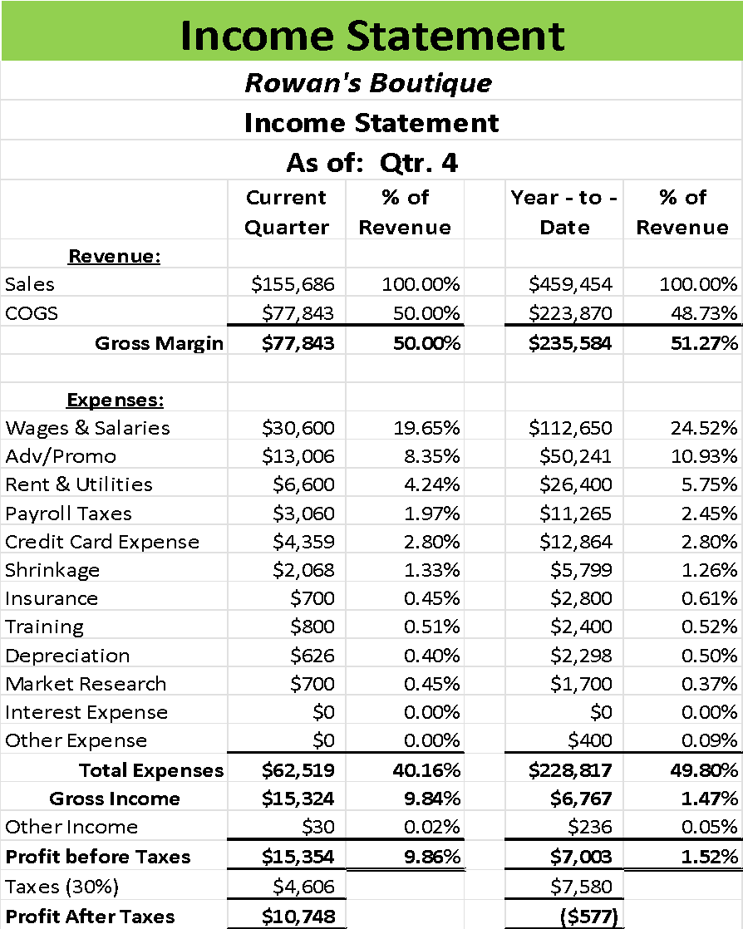

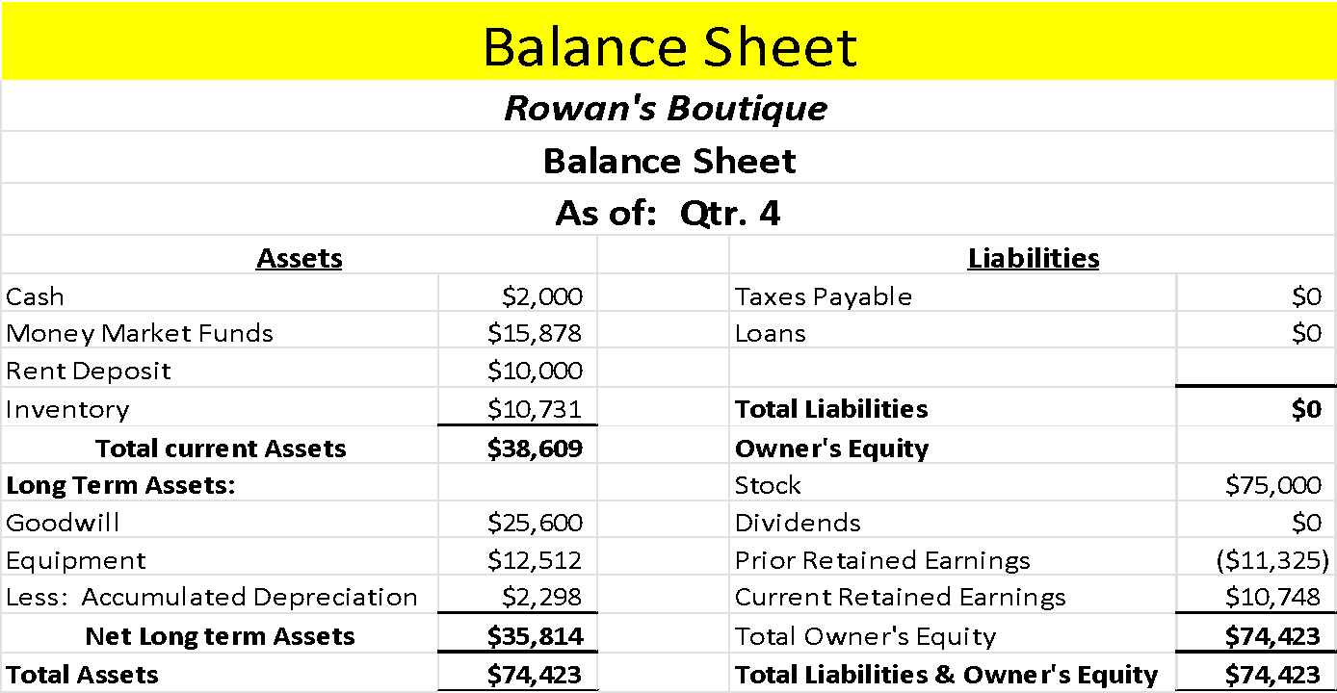

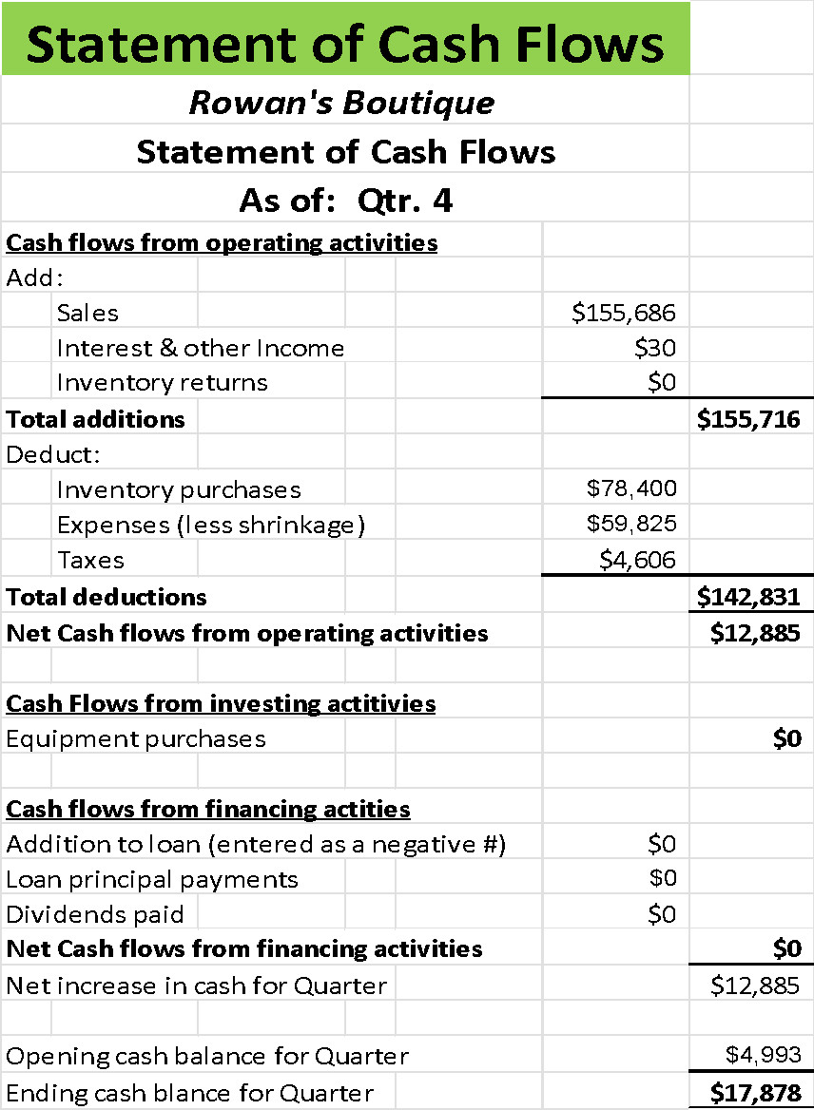

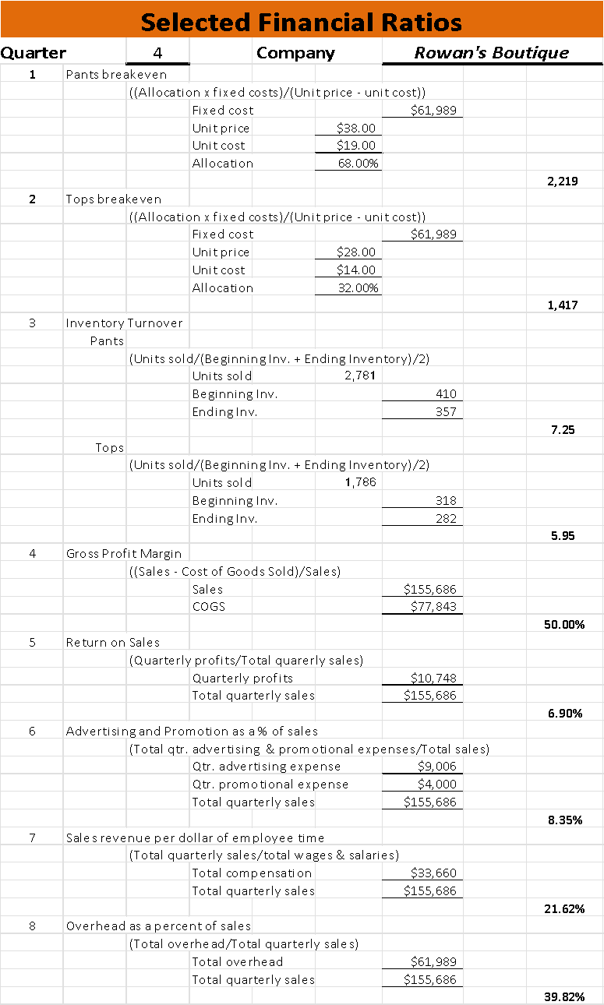

**Quarter: 5 Industry: Retail Company: Rowan’s Boutique**

**Operations**:

The previous quarter received a record number of sales. In total, Rowan’s Boutique made $155,686, with each employee selling $31,137 worth of merchandise. This was due in part to the holiday promotion being provided to go along with the season as well as ensuring there was adequate inventory to go with. There were some complaints from the customers regarding the pushy employee, one more quarter with more responses, the employee will be let go. Going into Quarter 5, it will be the beginning of the new year, and a sharp drop in demand is projected.

According to an article written by Irem Akdere Cinga, a Marketing director for Invent Analytics, “*The more accurately retailers forecast demand and plan accordingly, the chances are higher for enhanced customer satisfaction, increased inventory availability, and top-line growth*.” (Cinga) With this, accurate demand projection is paramount to proper ordering to maintain inventory. However, the boutique is also dependent upon having the latest designer brands as well that fit along with the seasons. According to an article written for an online fashion school “*Typically, high-end brands release about 5-6 collections a year: Fall, Winter, Spring, Summer, and Resort also known as Cruise. The Resort is an “in-between” collection that goes beyond the traditional fashion calendar*. “(Italian) So the ideal inventory for the boutique is to have some left over every quarter, but not a substantial amount that could take up valuable inventory space.

To keep up with the normal demand expected going into the next quarter, the next inventory purchase will be to get the inventory to the normal amount. So, 1,718 tops and 2,643 pants will be ordered, this will bring the inventory total of tops to 2,000 and bottoms to 3,000. In the case sales are low, there will be inventory left over so the next order will be a bit smaller if orders are low. The return policy will remain at 30 days with receipt, as shrinkage only cost the business $2,068 this quarter, which is only around 1.3% of the total expenses.

**Pricing**:

The price of $28.00 per top and $38.00 for bottoms will remain for the next quarter, as this is providing great profit margins for the business. Currently, the price of acquiring each top is $14, making the sale price of $28.00 around 50%, which is an ideal margin in the retail industry. The same concept for the pants, as the cost of acquiring $19, making the sale price of $38.00 a profit margin of 50%. For these reasons, the cost is still a reasonable price for the market and making the business money, so it will remain.

**Marketing**:

The main three channels that have provided the most exposure for the company while also being the most reasonably priced have been established. In addition to the Website, social media, and flyer distribution selections, the shopping mall also came with advertisements in the Merchants Association with flyers, so there is also an element of free exposure. The budget is at around $9,000 to pay for the website, social media sites and flyers, with another $2,000 to be allocated to the updating of the displays for the new year and subsequent holidays. Also, a logo has been established, which should also continue to set the boutique apart from its competitors. This makes the total marketing budget less than 10% of the expenses, which is fantastic for a marketing budget. The boutique initially imposed a No Discount policy during start up to keep the value of the brand, and now that the holiday season is over and there is not an overstock of inventory from the season, the 10% discount will be removed.

**Staffing**:

Last Quarter, there was an issue with an employee receiving kickbacks for pushing certain goods. Since there was an element of doubt that the employee was knowledgeable of the illegal act, a blanket statement was put out to address all staff that kickbacks are illegal and cannot be received. The punishment would be termination, as stated to all employees. This gave everyone equal opportunity to take responsible actions and not participate in the kickbacks. It was then reported that there were subsequent complaints from the customers regarding being pushed to buy certain items. The complaints pointed to the same employee that was initially witnessed taking the kickbacks being the salesperson pushing product too hard. So, there will need to be a decision made to keep the employee or fire said employee.

According to an article written by Ruth Mayhew, “Consistent application and enforcement of workplace policies is the responsibility of human resources, department supervisors and managers.” (Mayhew) This means that since this policy of everyone getting an equal chance at honesty but then the same employee breaks policy again, it’s the job of the manager or in this case, the owner, to enforce consequences from policy. Kickbacks are illegal, so receiving them is a fireable offense for this business. In addition, there is another issue at hand. By choosing to fire said employee, it could bring down morale since they were a top earner for the business. According to an article written by Natalie Cusson and Kelly Main for Forbes Advisor, “*Monetary incentives in the workplace can play a powerful role in recognizing and motivating employees*.” (Cusson/ Main) While just gratitude is a nice gesture, it wont retain any employees who may feel it was harsh to fire one of the top earners.

Since there was ample warning and its best business practice to follow through when there has been a witness to repeated policy violations, the employee will be terminated. In addition to terminating said employee, there will be a two dollar raise applied to all other employees, for a magnificent job well done for the first year’s sales. This will increase employee morale and will compensate them more as the boutique will seek to hire a replacement in the next quarter. This brings their hourly wage to an extremely competitive rate and if the business continues to do well in the future, the employees could be making much more since they made around $31,000 per employee last quarter.

**Finance:**

This last quarter, there was still no loan to be taken out. The business is experiencing increasing profits after expenses, with last quarter experiencing an increase from $4,993 to $17,878. This was due to increased prices and seasonal purchases for the holidays. If this trend continues, it’s possible that the Boutique may not have to take out a bank loan at all. So now the question becomes of another choice; should a dividend be paid out to the investors who helped keep the business afloat during the first year while the business was working towards profitability? There are several choices, pay out an amount, not at all, or set a goal and then pay out after the goal has been achieved.

There is also the question of why the boutique should pay out a dividend at all. The business was started by an angel investor, who was willing to invest $25,000 in exchange for 50% ownership of the company. According to an article written by Kimberlee Leonard, “*Companies that pay dividends are essentially distributing some of that business value back to its owners*.” (Leonard) So not only is the investor going to get a repayment of their investment, but the money is coming back to the business. In another article written by Tanya Chhabra, “*angels can expect a combined annual return of around 27%*.” (Chhabra) So 27% of the current profits would be around $4,800, which is a bit big of a payment to make out of just $17,000 of the current profit.

For this reason, a small payment will be made with the promise that the payments will build up to a proper dividend payment for the investor, if profits continue to grow. This will allow the investor to in turn keep helping the business but also provide much needed resources such as contacts and exposure by spreading the word about the boutique. The amount paid will be a meager $1,000, but this payment is made in good faith to prove the business is profitable by Year 2 and comes with the promise of an increase in the amount paid. If inventory management continues to stay with the current demand and certain employees have been handled to help prevent any returns that could hurt profits, there should be healthy growth throughout Year 2.

**Special Decision - Purchasing Policy**

Even in the designer retail industry, there is always an awareness that not all customers that come into the boutique are going to be able to afford the clothing that is being offered. With designer brands at the full asking price and no discounts the normal offering at Rowan’s Boutique, some customers do come out empty handed because they cannot afford the asking prices. So, it was worth the attention when a representative from the small garment cooperative in the local area came to the boutique with a great offer. The offer is to carry a line of products that are from the “cottage industry” that look just like the high-quality brands already offered, but cost much, much less to produce. Additionally, they are offering a rebate of 10%, up to $1,000 if the business takes on the product line. Upon asking other retailers in the industry who have taken the deal, it's a wonderful company that helps to employ those who are unemployed due to factory shutdowns. The only issue is customer acceptance, but once that challenge is dealt with, the product line is a great addition.

So, the decision will be made to take the product line at either 15%, 30% or 50% of all the inventory of the store, or to turn them away. Now, while the rebate sounds great, it caps out at $1,000 and only a percentage of the sales is going towards the rebate. Also, if there is too much inventory taken out to supply cottage industries, the designer brands that are sold at the boutique could take issue because they aren’t getting the shelf space they need. So, the decision must accurately reflect how many customers are going to take advantage of the new line and what percentage it would look like that's going to be eliminated from the designer inventory. The designer brands also have rebates given out and give opportunities to participate in cooperative ad campaigns, so losing designer loyalty could also become a tremendous issue.

The first thing that must be established is what cottage industry goods are. According to an article written by Will Kenton “A cottage industry is a small manufacturing business that is owned and operated by an individual or a family, typically operating out of a home rather than a purpose-built facility.” (Kenton) This means that the goods are typically handmade or close to, they integrate most of the business structure into the business, and considering the one in question is part of a cooperative, there are multiple small businesses involved. This cooperative also helps with unemployed factory workers, so there is a ton of good this cooperative is doing. Also the cooperative stated they worked with several churches, so working with them and bringing the product line into the boutique could also strengthen ties with the community.

This partnership will enable the strategy of co-branding, considering there is the designer brand and now the cottage brand being brought into the mix of the boutique. In another article published by Will Kenton, “co-branding as a strategy seeks to gain market share, increase revenue streams, and capitalize on increased customer awareness.” (Kenton) This means that because people are aware of the cottage brand, they will come to Rowans Boutique for it and then people will come for the designer brands, expanding awareness of the business, and expanding the demographic that will take advantage of both. It will also directly appeal to the customers who find the pricing of the designer goods too high.

With this research in mind, the decision will be made to feature the cottage brand goods in the boutique. However, the owner does not want to experience anything negative with the designer manufacturers, so the lower selection of 15% of inventory being the cottage industry and the rest continuing to be designer will be made. Since the rebate is only $1,000, is not a huge amount, so taking up any more inventory space could be detrimental to the business. While the boutique does want to increase customer awareness and enhance the relationship with the community, it does not want to short expectations when the customer does come to purchase. So by offering a portion of the inventory space for the new product, there is a mix of the best of both worlds, even more advertising and awareness being made, this decision should be beneficial for all parties.

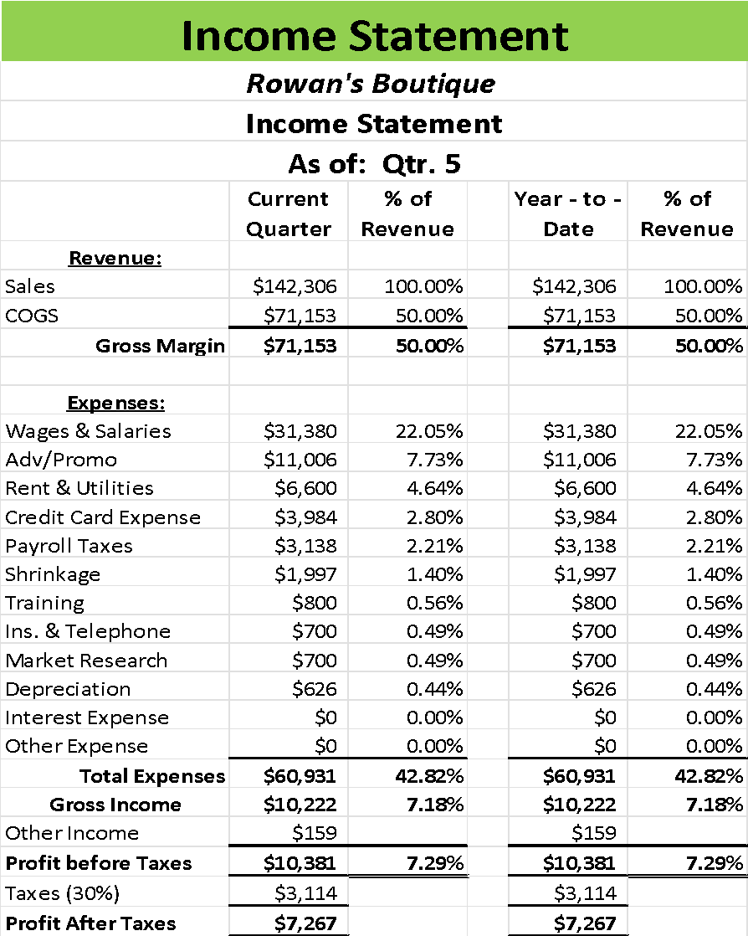

| Balance Sheet | | | | |
| --- | --- | --- | --- | --- |
| ***Rowan's Boutique*** | | | | |
| **Balance Sheet** | | | | |
| **As of: Qtr. 5** | | | | |
| **Assets** | |  | **Liabilities** | |
| Cash | $2,000 |  | Taxes Payable | $0 |
| Money Market Funds | $21,652 |  | Loans | $0 |
| Rent Deposit | $10,000 |  |  |  |
| Inventory | $11,850 |  | **Total Liabilities** | **$0** |
| **Total current Assets** | **$45,502** |  | **Owner's Equity** |  |
| **Long Term Assets:** |  |  | Stock | $75,000 |
| Goodwill | $25,600 |  | Dividends | $1,000 |
| Equipment | $12,512 |  | Prior Retained Earnings | ($577) |
| Less: Accumulated Depreciation | $2,924 |  | Current Retained Earnings | $7,267 |
| **Net Long term Assets** | **$35,188** |  | Total Owner's Equity | **$80,690** |
| **Total Assets** | **$80,690** |  | **Total Liabilities & Owner's Equity** | **$80,690** |

| **Statement of Cash Flows** | | | | | |  |
| --- | --- | --- | --- | --- | --- | --- |
| ***Rowan's Boutique*** | | | | | |  |
| **Statement of Cash Flows** | | | | | |  |
| **As of: Qtr. 5** | | | | | |  |
| **Cash flows from operating activities** | | | | |  |  |
| Add: | |  |  |  |  |  |
|  | Sales |  |  |  | $142,306 |  |
|  | Interest & other Income | | |  | $159 |  |
|  | Inventory returns | |  |  | $0 |  |
| **Total additions** | |  |  |  |  | **$142,465** |
| Deduct: | |  |  |  |  |  |
|  | Inventory purchases | |  |  | $74,269 |  |
|  | Expenses (less shrinkage) | | |  | $58,308 |  |
|  | Taxes |  |  |  | $3,114 |  |
| **Total deductions** | | |  |  |  | **$135,691** |
| **Net Cash flows from operating activities** | | | | |  | **$6,774** |
|  |  |  |  |  |  |  |
| **Cash Flows from investing activities** | | | | |  |  |
| Equipment purchases | | |  |  |  | **$0** |
|  |  |  |  |  |  |  |
| **Cash flows from financing activities** | | | | |  |  |
| Addition to loan (entered as a negative #) | | | | | $0 |  |
| Loan principal payments | | |  |  | $0 |  |
| Dividends paid | |  |  |  | **$1,000** |  |
| **Net Cash flows from financing activities** | | | | |  | **$1,000** |
| Net increase in cash for Quarter | | | |  |  | $5,774 |
|  |  |  |  |  |  |  |
| Opening cash balance for Quarter | | | | |  | $17,878 |
| Ending cash balance for Quarter | | | |  |  | **$23,652** |

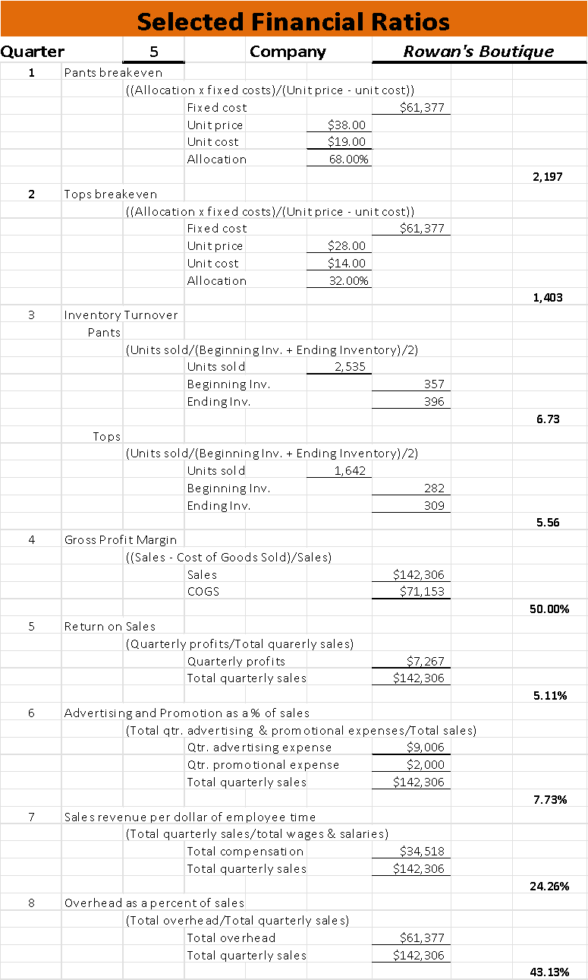

**Quarter: ___6___ Industry: ___Retail___ Company: Rowan's Boutique**

**Operations**:

This previous quarter experienced a good number of sales, but the number was lower than the previous quarter. The boutique had ordered 1,718 tops to equal a total of 2,000 in inventory for the quarter and 2,643 bottoms to equal 3,000 to maintain the normal inventory levels. There was a projection of a slight increase in demand, and what was experienced was just a slight increase in demand. This upcoming quarter sales are expected to increase, there is still feedback regarding customers being unable to find the pants or tops they prefer. The decision for this quarter is whether to order more inventory, alter the return policy and consider if the hours of business that the boutique is open for are optimal for the customers.

Considering there will only be a slight increase projected in the demand for the next quarter for the boutique, the order being made will not be a big one, but the normal size to bring inventory levels back up to the normal levels of 2,000 pants and 3,000 bottoms. This is due to the demand being projected to 1,642 tops and 2,535 bottoms for the next quarter. The remaining inventory will ensure that if there is a sudden increase in demand during the quarter, the boutique will not experience an outage in their inventory and will be able to meet customer demand. The hours of operation will remain at 10 hours open per day, as this is giving customers ample time to visit and considers customer foot traffic increasing in the evening hours during the week due to most of the target customers still being at work. The return policy will remain in place not only due to the fairness of the policy, but the boutique also had just let the pushy employee go, so there could be some customers thinking twice about the product that was pushed onto them.

**Pricing**:

The pricing of designer clothes will remain at $28.00 per ton and $38.00 per bottom. This provides a good profit margin of 50%, since the tops cost $14 to produce and the bottoms cost $19. 14 times two brings the amount to 28 and 19 times two brings the amount to 38, so there will be a profit of $14 being made per sale of tops and $19 profit being made when a bottom is sold. This amount not only covers the cost of the product but is also making enough profit to where the business is slowly growing in profits over time as well. So, for these reasons, the pricing will remain unchanged for this quarter.

**Marketing**:

The current marketing strategy features a website, strong social media accounts, and flyers being passed around town and hung up on the latest offerings of Rowan’s boutique. This marketing strategy brings about awareness and brand recognition, which translates into increased sales. With the establishment of a logo, the boutique has set itself apart from the competitors by conveying the message of designer brands but in a beautiful, small-town boutique feel. The marketing strategy has been working tremendously for the boutique, so for these reasons the current strategy will be kept, and no further changes will be made this quarter. So, $4,000 will be allocated to maintaining the website for online sales, $3.004 will be allocated to running and maintaining social media accounts, and $2,002 will be allocated to the development and passing out of flyers. The promotions will also remain unchanged, with just a $2,000 update to the displays of the business. Rowan’s Boutique will not be offering any discounts this quarter, as discounts will cheapen the designer brands and will form a habit of customers expecting discounts all the time. Discounts will only be handed out during the fourth quarter, during the holiday season, to entice holiday shoppers to come to the boutique.

**Staffing**:

Last quarter, a discussion was held with a particular employee about pushing products onto customers to get them to buy more while the employee was receiving kickbacks from the manufacturer to push the product. After giving the benefit of the doubt and informing all the staff that kickbacks are illegal and will not be tolerated, for if witnessed to receive kickbacks or customer complaints are received about getting product pushed onto them, that employee will be let go. Unfortunately, the same employee that was the subject of this issue last quarter continued to push products and receive kickbacks. They have been let go and now the decision must be made to whether to replace said employee or go without for the next semester.

Previously in the beginning year of the company, it was established with research that the optimal level of part time employees on the sales floor on any given day in addition to management and full-time salesclerk was to be around 2 part time employees per hour. This gave ample room for customers to walk around, enough employees to help should there be multiple customers in the building at once. If the boutique were to experience a drop in the number of employees available per hour, there could be sales missed. In an article written by Vivian Tejeda for Shopify, “Employees become overworked and stressed, which then leads to quitting, low morale, and disengagement.” (Tejeda) So to avoid employees experiencing being overworked and lowering morale, the boutique must hire a replacement to bring the optimal level of employees to 2 per hour in addition to management and full-time workers. The impact of losing and then hiring another employee shouldn’t affect profits for the business either. According to an article written by Marshall Fisher “though it takes time to reap the benefits of adding workers in many industries, the payoff is immediate in stores that can productively use extra staffing.” (Fisher) Since there is plenty to do on the sales floor for each employee, this extra employee will be used immediately and continue to drive up productivity.

With this research in mind, the decision has been made to hire another employee to bring the optimal level per hour back up to 2 employees. This should positively impact employee morale and will show that even though policy must be followed through, the owner is not going to let the remaining employees be negatively impacted. The newly hired employee will begin training as well as the other employees will continue with training. This will bring the total amount of compensation for the part-time employees to $18,720 and the full-time with management will remain at $15,000. This will help to keep increasing sales and drive profitability.

**Finance:**

As stated in the previous quarter, there would be an amount beginning to be paid out to the angel investor, but that amount would increase as profits during Year 2 continued to rise. Last quarter, a meager $1,000 was paid out. This quarter has experienced an increase in profit, so the decision this quarter will be to either pay out the same amount or increase the amount being paid out. While there is an option to pay back nothing, it would be a terrible decision not to, considering the boutique just started paying dividends.

According to an article written by J.B. Maverick “Companies that increase their dividends send a positive signal to investors and analysts that the company can maintain growth and profitability into the future.” (Maverick) So paying an increased payment is a positive signal to the angel investor. In an article written for the U.S. News by Coryanne Hicks, Daniel Milan, a managing partner of Cornerstone Financial services, is featured. The service handles investments and gives advice on which investments to take, Milain states in the article they suggest to their clients to find companies who have sustained dividend growth each year. (Hicks)

With this research in mind, the boutique has reached two decisions. The first decision will be to continue to pay out a dividend. This will keep faith with the angel investor and excite them to see the payments increased, it means the business is healthy and doing well. So, the amount will be increased as well. This decision will bring Rowan’s Boutique to payout $2,500 to the angel investor. There will be a guarantee that as sales increase the dividend payment will be increased as well.

**Special Decision – Pushy Employee**

Poverty can drive anyone to do things they wouldn’t normally do to survive. In some cases, this can mean that employees could potentially steal from their workplaces to either help themselves or someone close to them. Other times, employees can commit theft out of a sense of not being properly compensated for the work they do or just out of malice. The owner of Rowan’s Boutique had recently noticed that while they are out to lunch for an hour, sales take a strange little dip for the duration of the lunch hour. One of the part time employees is always in charge but then the owner begins to take suspicion after one of employee’s children were witnessed at the movies wearing clothes from the boutique by the owner. In addition, upon return during the lunch hour, the owner witnessed the same employee leave $40 out of the register instead of ringing it into the register. Advice from a friend who is also a police officer says that the owner should take swift, immediate action. But there should be some mindfulness in approach, considering the employee is a single parent and is getting help from several religious organizations.

There are several avenues that could be taken when addressing the employee. There is the option to lay off the employee under the guise that business has been slow. Also, the option of notifying police or having the friend who is also an officer interrogate the employee. The option of talking to the employee or questioning him from the owner is available as well. As always, there is an option to just do nothing because there is not enough evidence to prove anything. In any case, action must be taken because employee theft cannot be tolerated in any way.

According to a survey conducted by the National Retail Federation, “*each dishonest employee case costs retailers around $1,551.66, which is lower than in 2016*.” (NRF, p. 9) Which is a significant expense for any small business. While the current issue with the employee is not costing the business anywhere near that amount, they could potentially wind up costing the business quite a bit. Not to mention the additional cost of losing customers who have experienced having product pushed on them. Also, there is the cost of erosion of trust between an employer and the employee.

However, handling the employees in a way that does not result in their leaving the company is a priority, so finding a way to properly address a policy violation is important. But also, not having enough seriousness in handling of the problem could result in even more employees engaging in the violation. According to an article written by employment law office Lindhorst and Dreidame,” a warning or putting them on probationary status may be appropriate for a minor policy infraction.” (Lindhorst) Even if clothing was possibly stolen, it could just result in a minor policy infraction since the employee may be in hard times.

The response to this situation selected was to sit down and talk to the employee about the situation and bring up the possible theft. While there are no actual accusations being thrown around, there is still enough suspicion to need to speak with them. There is not enough proof to engage any authority like police or the police friend, so that option is not going to work. Also, laying off the employee could have negative consequences for the organizations they work with, considering they are public organizations that could make an order with the business. Always, doing nothing is never a good option, as the loss could continue negatively impacting the business.

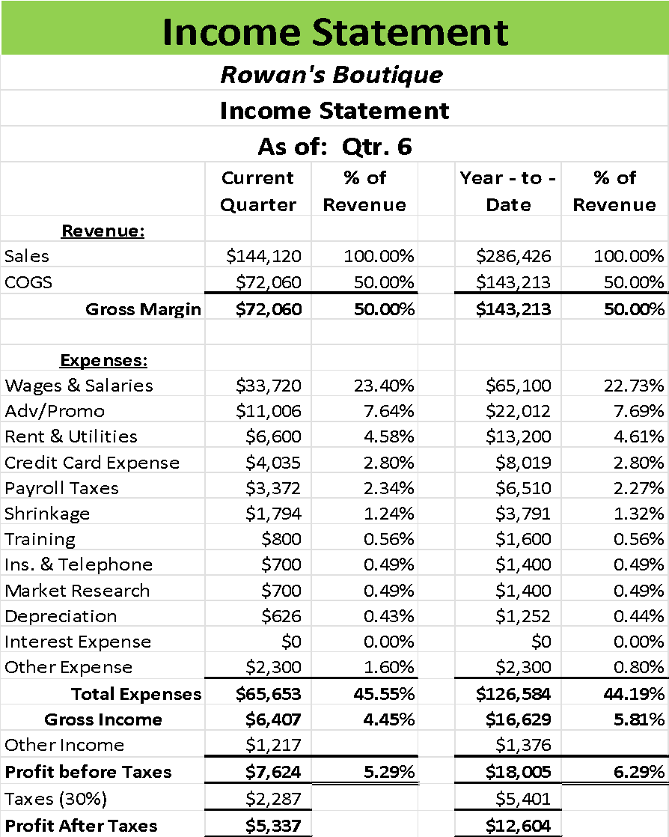

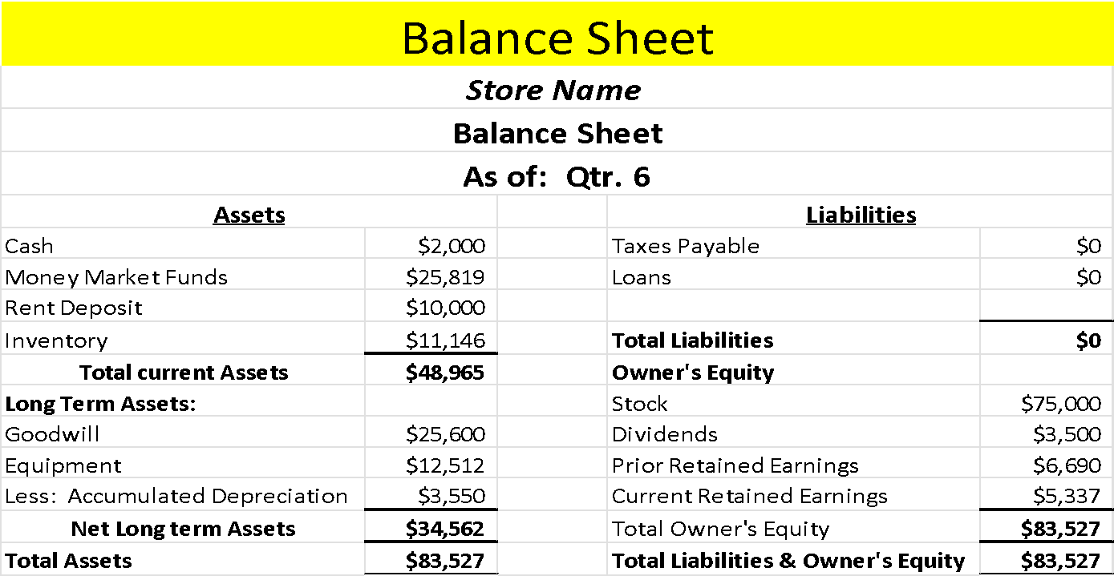

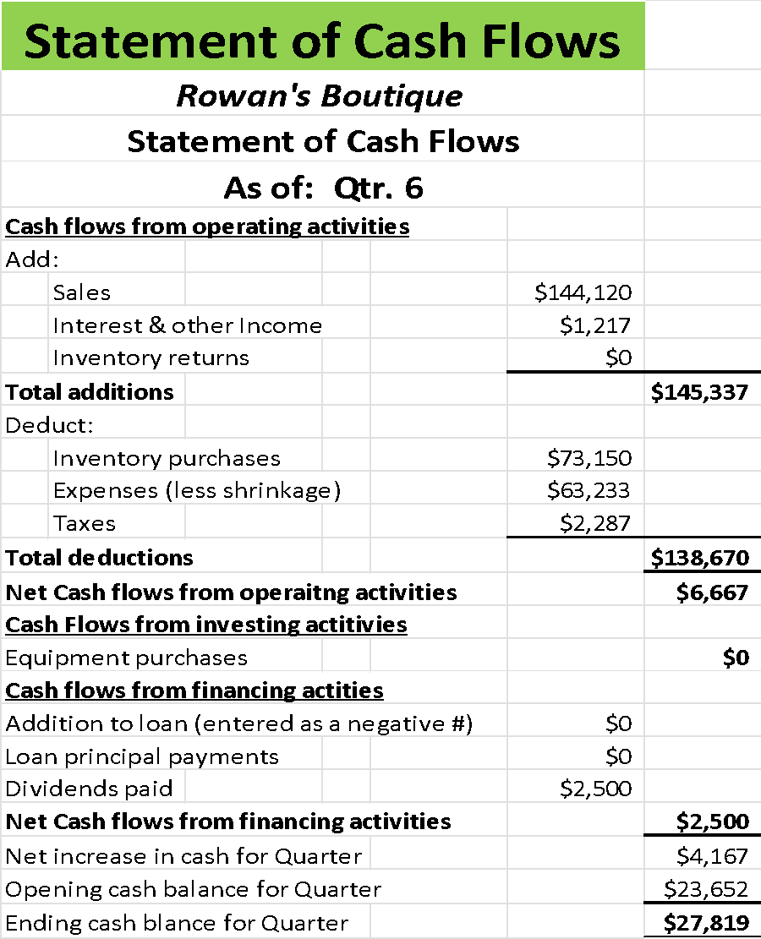

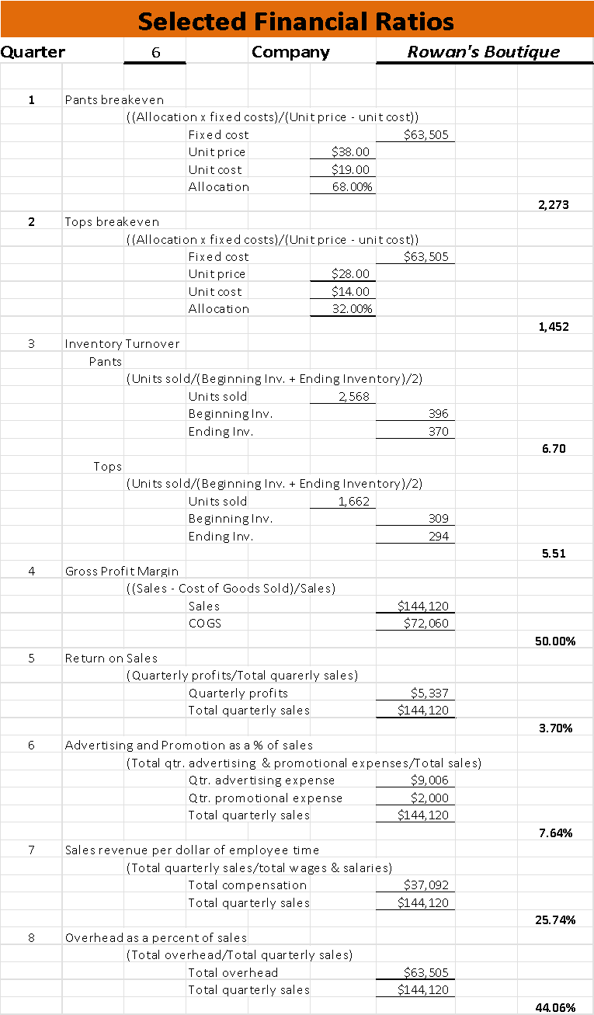

**Quarter: __7____ Industry: _Retail__ Company: Rowan’s Boutique**

**Operations**:

The previous quarter was a good quarter for sales, total revenue amounted to $144,120 with 1,662 tons sold and 2,568 bottoms being sold during the previous quarter. These sales are tremendous and align directly, which is what was forecasted, with the addition of the newly purchased cottage industry goods, appealing to customers with a little less money to spend. The decision now will be made in inventory orders, whether to keep ordering with the normal inventory amount in mind or alter the amount due to the new product line being launched. There are also decisions to alter the hours or the return policy as well.

Even though there is the addition of the cottage industry clothing, there is still a great demand for the regular designer products as well. The current return policy is firm but fair and the hours of operation remain at optimal levels. Thus, the decision has been made to keep the current ordering process and order up to the normal inventory amount to retain proper levels. 1,691 tops will be ordered to bring the inventory amount up to 2,000 tops and then 2,604 bottoms will be ordered to bring the amount in the inventory up to 3,000 bottoms.

**Pricing**:

Currently, the pricing has remained unchanged, with tops priced at $28.00 and bottoms at $38.00. This provides a 50% profit margin for both products, which is fantastic for designer clothing. There would be great harm done to the business if the prices were to be reduced, cheapening the brand, and increasing them, eliminating more customers that would not be able to afford the more expensive price. Additionally, the profits already being experienced have allowed the business to see the start of profits at the end of Year 1 and have continued to grow profits from not altering the price at all. So, with all these elements in mind, the pricing is going to remain unchanged. Considering the Boutique is the only retail business offering designer clothing in this market, the pricing does not have to be competitive.

**Marketing**:

The current marketing strategy is working while making a great amount of money. While the boutique is not spending the most out of all the stores in the market, the $9,006 that is spent on advertising has enabled quite a bit of brand recognition in the community. So, while the boutique is taking advantage of the website, social media, and flyers, it also gets free advertising from the Merchants Association as part of selecting the shopping mall as the business’s new home. As stated in the startup decisions, the target demographic for this business normally would not be watching television or listening to the radio, so spending money on those channels would garner some attention, but the attention garnered would not be enough to cover the cost of utilizing those channels. The direct mailers were nice in the beginning, but having flyers drummed up more business for the boutique than the mailers. So, the decision has been made to keep the marketing strategy the way it is along with the promotions, as both are at optimal levels. A discount will not be offered again this quarter, as the discounts will appear during quarter 4 when the holiday season is upon the business.

**Staffing**:

Last quarter, a new employee was brought on to replace the employee receiving kickbacks. This brought the number of employees available to 2 per hour, which is the optimal level for the boutique. The decision this quarter will be to bring in new employees, let some go, or remain at the same amount. Also, the decision will be made on the wage to pay the employees with. Considering the store is at an optimal level with employees, morale is good amongst them and there is steady training for all, there will not need to be additional hirings for this quarter. The amount being paid to employees is $12.00 per hour for their work, which is the most competitive wage being paid in the local retail market. This wage reflects the good job all the staff does but also reflects the type of clothing they are selling; more expensive clothes being sold means the one doing the selling should be paid more as well.

**Finance:**

Last quarter, it was determined that the dividend amount paid out to the angel investor would be increased to $2,500 with the expectation that if profits increased, so would this amount. However, profits were right around where they were in the previous quarter. So, the current amount being paid out in dividends will remain at $2,500 as the business maintains this profit level. There is a projected increase in revenue going into quarter 8 so if the profits are increased from quarter 8 sales, then an increased dividend will be paid at that time. So, the amount paid will not be changed this quarter and there will be an amount being paid out so further changes will be made to Finance at this time.

**Special Decision – Cooperative Advertising**

As the business continues to grow, so do the opportunities being presented to the business regarding advertising. Recently, Rowan’s Boutique has been approached with the opportunity to enter a great co-op advertising package, they will pay 50% of all the advertising that features their line of clothing for the next quarter. Ordinarily, the owner would agree immediately to take the deal, but there has been an issue with how the brand has been using their clothes and models. All the models are extremely beautiful, and the clothes featured are too tight, revealing a little too much. The ads have been branded as sexist in other cities and religious councils have objected to the ads in local media. Talking with customers, families and friends brings mixed responses, but there is a point in that the advertising part is lucrative and other brands do run these types of ads. Perhaps there is a middle ground to be found.

There are several different ways the Boutique could handle something like this. There is always the option to not take the deal, citing the way the models are dressed and behaving in the advertisements. But again, often brands make their advertisements to appeal to the demographic most reported to purchase the clothing. With designer brands, this was a norm until the opinion of society shifted to body positivity and setting realistic standards for how normal people look in day to day life. While there is an option to run all the ads possible, it would double the effect of the current advertising budget but would be shown during times when young adults and children would be watching television. In advertising, the ideal of not impacting the view of how a young adult may see their own bodies. The middle ground would be to ensure that the advertisements were run at times when impressionable young adults are almost never watching the television. This way, the business could still take advantage of the opportunity but also be mindful who is consuming the advertisement.

Before reaching a decision, several issues must be resolved first. There is the overall definition of what cooperative advertising is. In an article published by Neil Kokemuller, cooperative advertising is defined as “paid advertising messages with costs shared by retailers and manufacturers.” (Kokemuller) So the manufacturer pays a portion of the cost to advertise their products through the sellers. In this case, the manufacturer in question is offering to pay 50% of the expense, meaning that they will match dollar for dollar spent. This normally is an effective strategy, but the real issue lies not in the compensation being given, but what is being shown in the advertisements themselves.

Due to the risqué nature of the advertisements described, several religious councils have objected to the ads and feminists’ groups that have sounded that these advertisements are sexist. This is mostly because of the fact this could negatively impact the young adults who may see them and then develop disorders or negative body standards because of them. Not to mention the viewpoint of the religious councils, who strive to ensure that content shown in local media is of their approval. But when it comes to the young adult issue, there is merit in knowing they aren’t even watching television these days. According to an article published by Mark Sweeny for The Guardian, “*Viewers aged between 16 and 24 spend just 53 minutes a day on average watching traditional broadcast TV – a fall of two-thirds over the last decade – seven times less than those aged 65 and over*.” (Sweeny) So the demographic that these organizations are worried about don’t watch advertisements in the same way that is shown on television, for they do not watch television.

But the owner knows from experience that advertisements on social media platforms, the new primary spot for media consumption for the demographic of 16-24, are now pushed to customers in an algorithm. So, they are specifically targeted to users who have certain activities picked up by the algorithm like looking at the boutiques social media page or viewing their website. That could accidentally start pushing the risqué advertisements to the impressionable audience. The boutique is a member of the community and has been making a name for itself in responsibility and lawfulness. Having members of the community see the boutique run these ads could harm its image in the community overall.

With all this information in mind, the boutique is going to turn down the advertisements unless something less risqué can be shown, with realistic models and natural poses. This is because the boutique does have a responsibility to the community and the impressionable demographic. The boutique has also caught a lawsuit for calling out a school official for quid pro quo, another competitor for using the bait and switch tactic and enforcement of policy regarding employee illegal activity. Simply put, this business has always held an image of honesty, public responsibility, and ethical actions. Also given that the advertising budget of the boutique has been on the lower side since the business started, the dollar amount being matched would not equate to the amount that could be loss in sales because of a diminished public view.

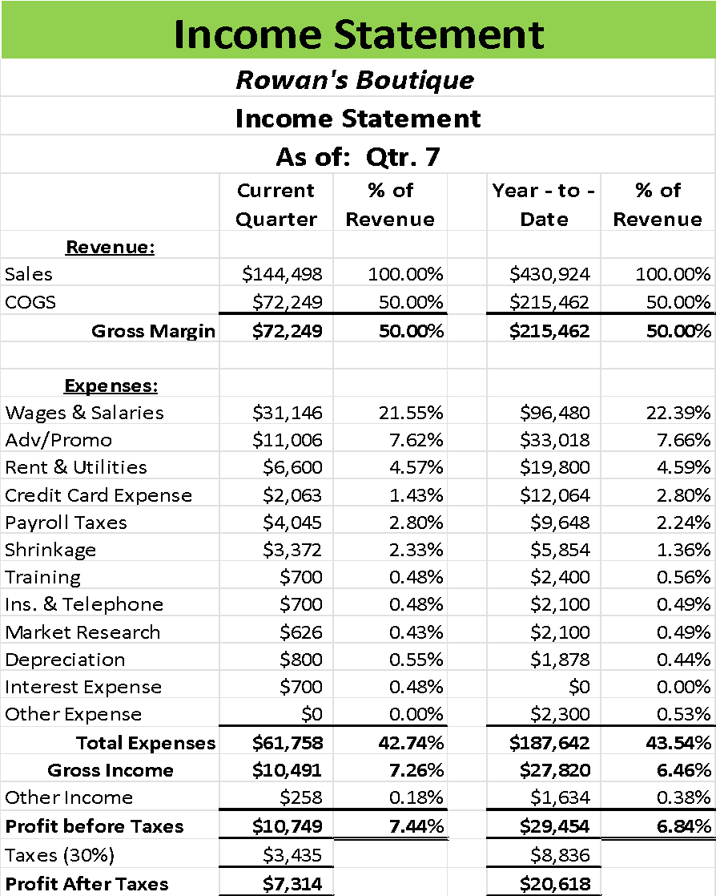

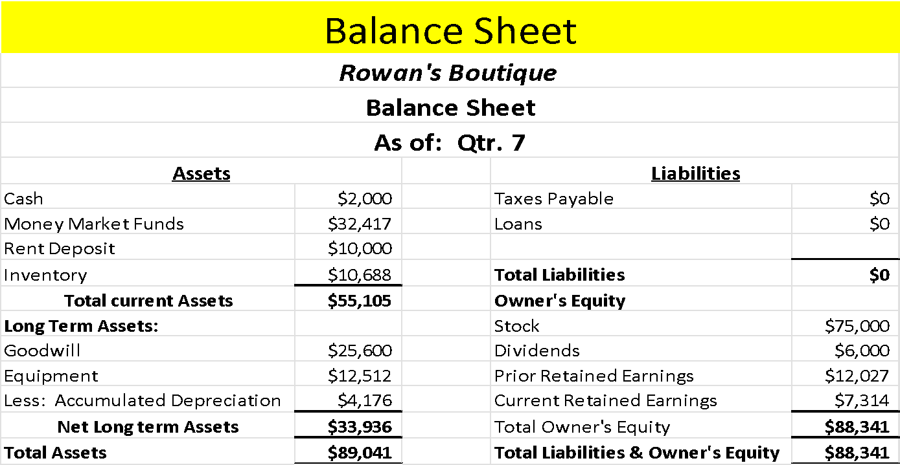

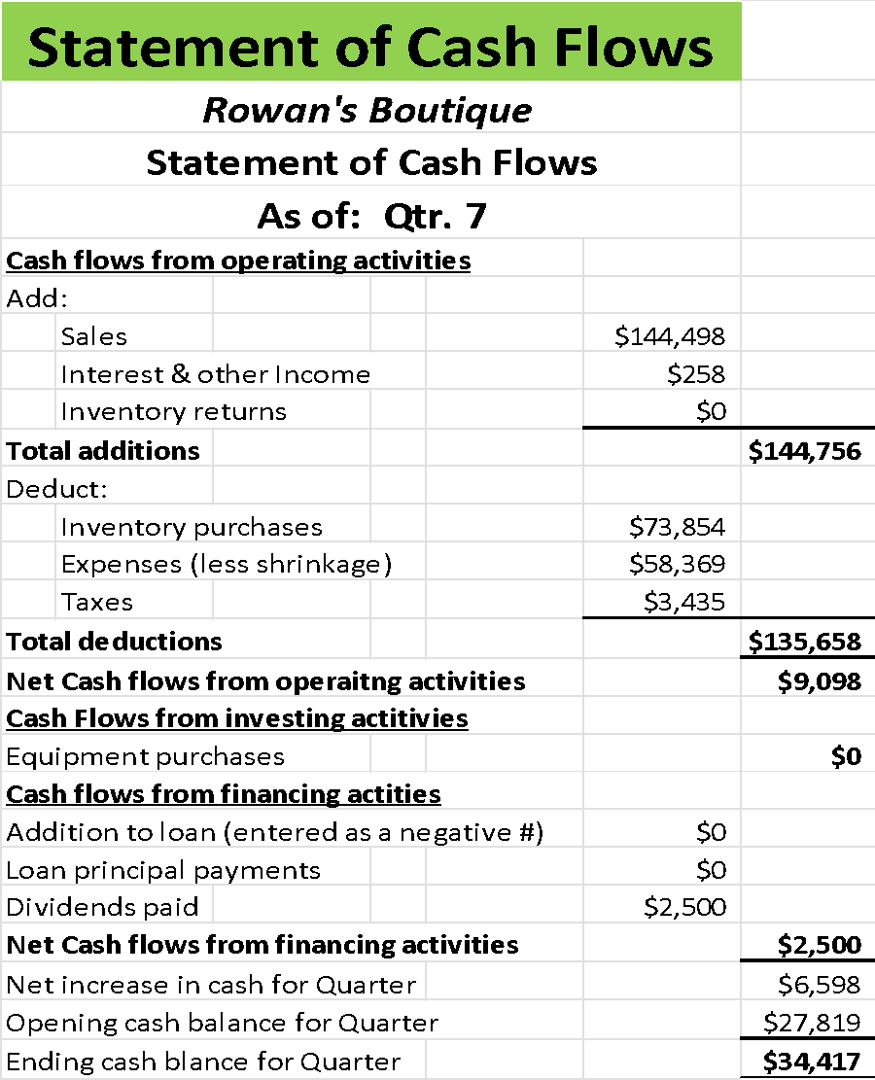

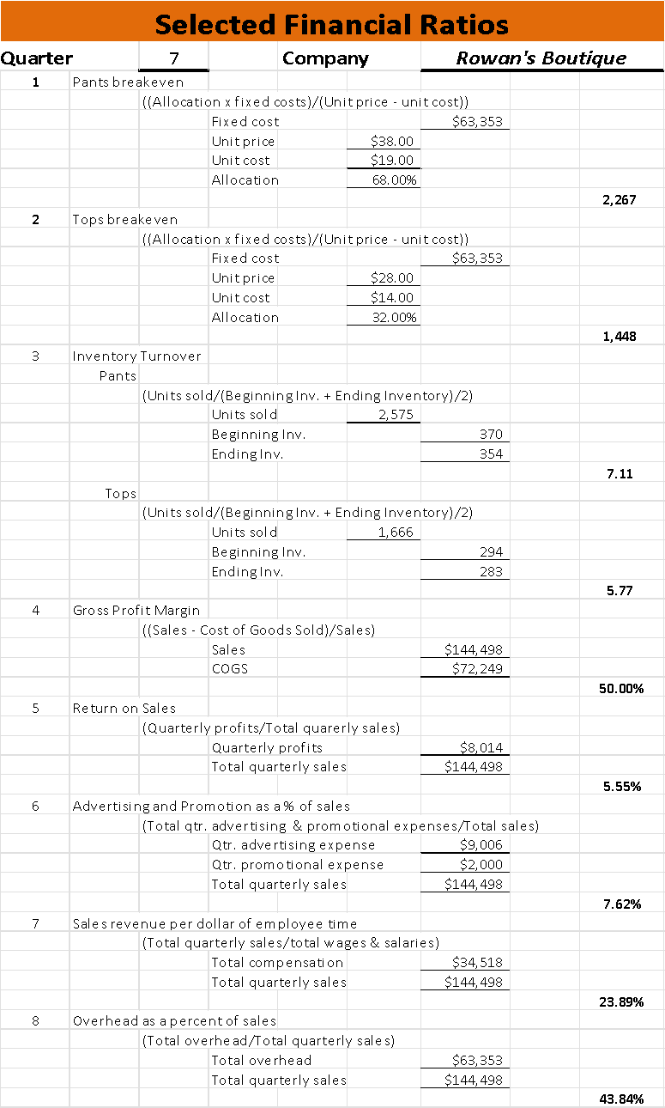

**Quarter: ___8___ Industry: ___Retail __ Company: _Rowan’s Boutique____**

**Operations**:

Last quarter, Rowan’s boutique had ordered 1,717 tops and 2,646 bottoms for the next quarter to bring the inventory level up to the typical amounts of 2,000 tops and 3,000 bottoms. Of that amount, 1,867 tops and 2,844 bottoms were sold, generating $160,348 in revenue. The return policy remained at 30 days with receipt and the policy remains to be respected by customers. The store hours were established to be open 10 hours per day, allowing customers to visit when they have the time in their schedules. Now some decisions will have to be made for the next quarter.

Due to the continued success of ordering up to an established inventory level of 2,000 tops and 3,000 bottoms, the trend will continue for this upcoming quarter. Even though it is a holiday season and sales are projected to be high, there is a healthy backstock that could last several days that can be used for the heightened demand if there are inventory issues. The return policy continues to be respected by all parties, so it too will be kept being fair but firm with late returns. The store will also remain open for 10 hours a day to give customers the opportunity to visit when their schedules fit him.

**Pricing**:

Last quarter, the decision was made to keep the current pricing for the tops and bottoms. Currently, the price customers must pay for a top is $28 and the bottoms are $38. This price allows for a 50% profit for every item sold, with the breakeven number of tops that need to be sold are 1,543 tops and bottoms sold are 2,308. This pricing and breakeven amount allow for the boutique to make plenty of money after costs are paid for, so the pricing will be kept at the current amount of $28 per top and $38 per bottom.

**Marketing**:

The advertising selected for this quarter will be the Website for $4,000, running the social media account for $3,004 and the flyers will cost the business $2,002, which will run a total of $9,006 for advertising. The decision will now be made to whether to offer a discount or not for the holiday season. There are ample reasons as to why a business should offer some sort of discount during this year. Typically, customers are going to be more willing to visit shops they wouldn’t normally visit to purchase select items for their loved ones. This is also a time of year where most luxury brands experience an uptick in sales, because of the demand increase to purchase luxury items for the spirit of the holiday season. So, for this reason, Rowan’s boutique is going to offer the 10% discount that they offered last year, as it garnered a significant portion of sales just by offering that small discount. While most businesses are going to offer higher discounts, to offer anything too high for a discount could automatically cheapen the product, leading to value perception issues in the future when the boutique no longer offers the discount. As such, the boutique is going to maintain the strategy of only offering this discount during the holiday season to prevent the habit of customers expecting some sort of discount no matter when they visit the store.,

**Staffing**:

Last quarter, two new associates were hired onto the team. This brings the part time coverage to two per hour. The wage was kept at $12.00 per hour for the part-time staff. The staffing levels remain at their optimal level of 2 per hour because of the number of sales that are being made per employee, which is around $32,070. So, no new employees will be hired. However, the training for the eight part-time employees will remain the same and continue so that they will continue to provide exceptional customer service.

**Finance:**

Previous quarter, a dividend of $3,000 was generously paid out to the angel investor, which of course was part of an established goal to work up to a certain percentage amount of the profits being made. This quarter, that trend will continue with a dividend of $4,000 paid out to the angel investor. This individual has been helping the business tremendously and has been extremely impressed with the business’s ability to start up and grow without the need for any other financial help than just the initial investment. Not having a bank loan to pay has played a tremendous part in the success of the business being able to start making profit and that profit continuing to grow. No loans meant no loan payment, and if the profits continue to increase, Rowan’s boutique may never need to pay a bank for any loan and pay just the dividends to the investor.

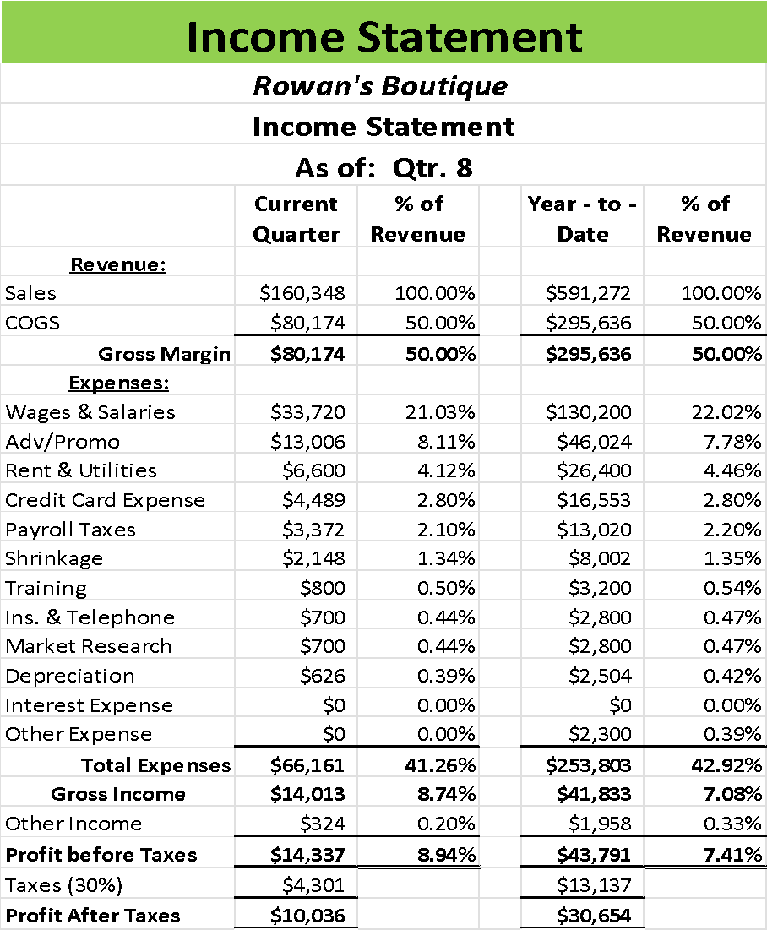

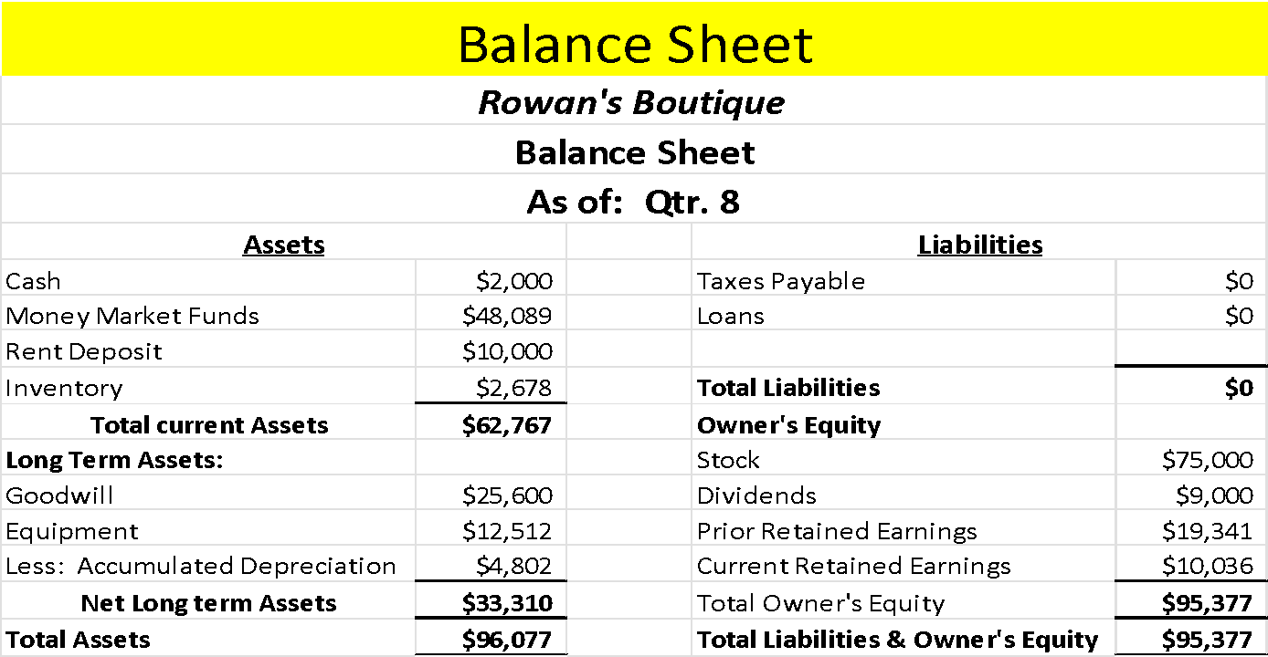

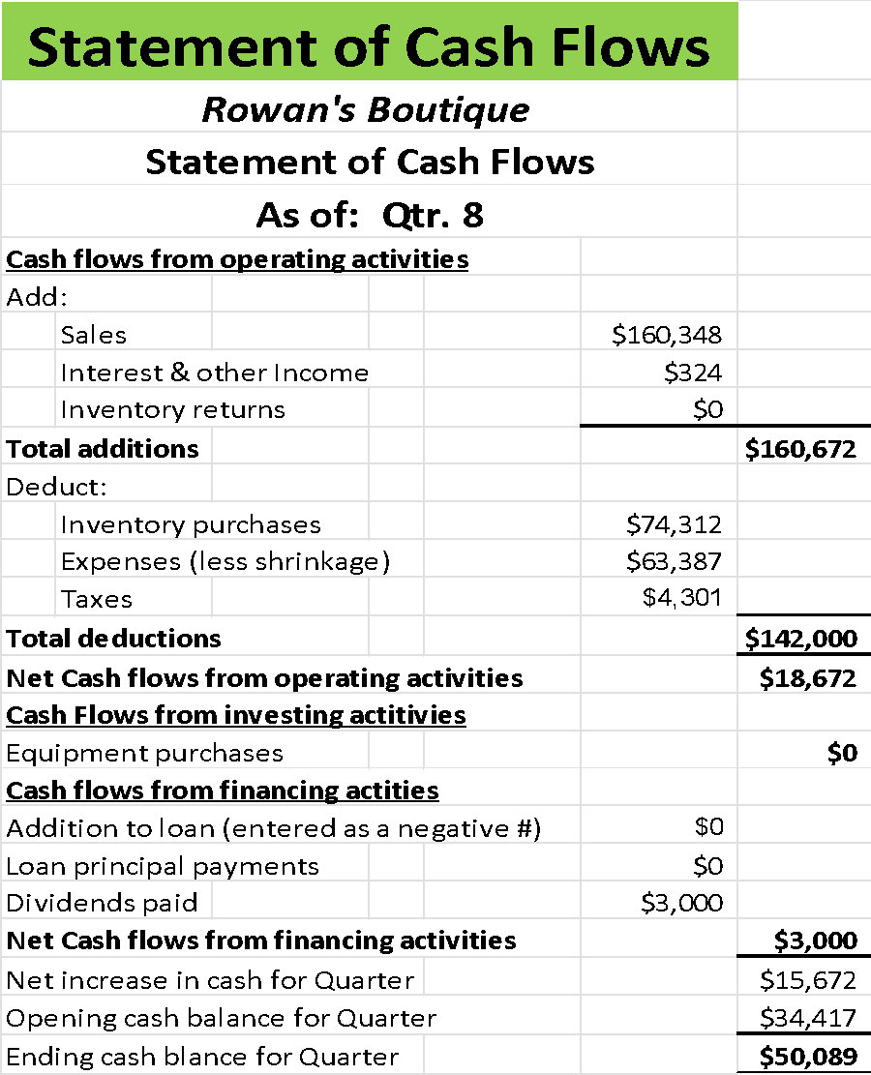

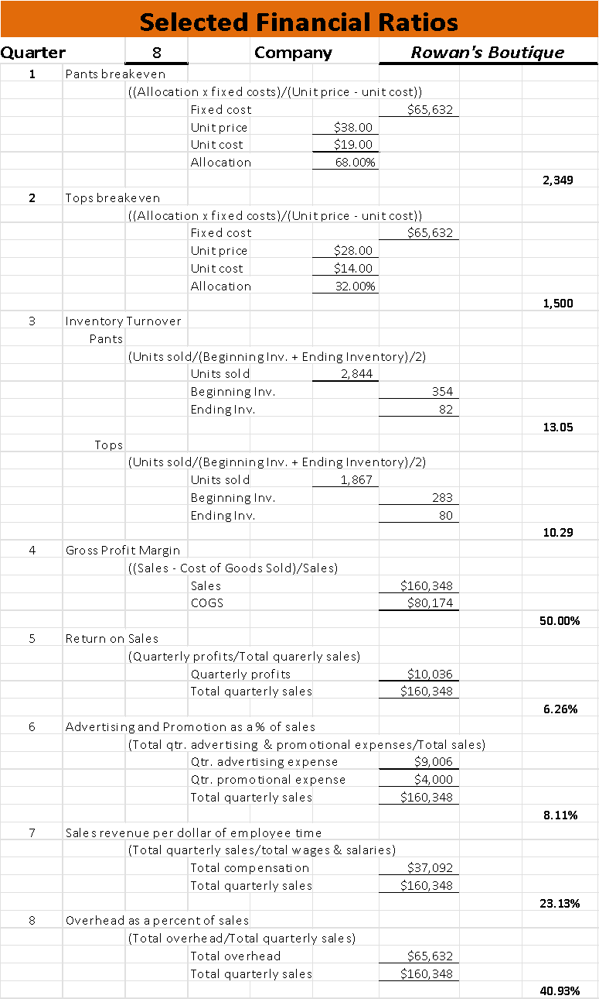

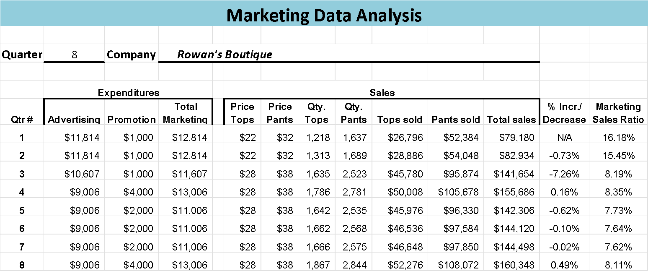

**Works Cited**

Administration, Small Business. *Fund Your Business*, 2023, www.sba.gov/business-guide/plan-your-business/fund-your-business#section-header-5.

Associates, Coxwell. “Kickbacks.” *Coxwell & Associates*, 2023, www.coxwelllaw.com/criminal-defense/white-collar-offenses/kickbacks/#:~:text=In%20the%20private%20sector%2C%20kickbacks,difficult%20after%20a%20prison%20sentence.

Association, National Educators. “Code of Ethics for Educators.” *NEA*, 202AD, www.nea.org/resource-library/code-ethics-educators.

Baluch, Anna. “Retail Inventory Management Best Practices.” Forbes, Forbes Magazine, 12 May 2023, www.forbes.com/advisor/business/retail-inventory-management/.

Banton, Caroline. “Equity Financing: What It Is, How It Works, Pros and Cons.” *Investopedia*, 20 Dec. 2022, www.investopedia.com/terms/e/equityfinancing.asp#toc-pros-and-cons-of-equity-financing.

Barbieri, Marlisa. “Costly Mistakes to Avoid When Pricing for a Luxury Design Startup.” *Entrepreneur*, 24 Oct. 2021, www.entrepreneur.com/starting-a-business/costlymistakes-to-avoid-when-pricing-for-a-luxury-design/381763.

Brandenburger, Alaina. “Clothing Brand Marketing Ideas That Work.” *Constant Contact*,

6 Feb. 2023, www.constantcontact.com/blog/clothing-brand-marketing-ideas/.

Accessed 21 May 2023.

Barrera, Thalia. “How Long Do Fashion Trends Last? Distinguish between Fads, Trends and Classics.” *The Tech Fashionista*, 22 May 2022, thetechfashionista.com/how-long-do-fashion-trends-last/#: ~:text=In%20the%20fashion%20world%2C%20a, often%20last%205%2D10%20years.

Brooks, Chad. “Tips and Tricks for Staffing Your Business.” *Business.Com*, 6 Mar.

2023, www.business.com/articles/how-to-staff-business/.

Bruce, Jenna. “Why Flyers Are Powerful Marketing Tools and How to Post Them Legally.” Home Page, 9 Dec. 2019, www.mediaspacesolutions.com/blog/why-flyers-are-powerful-marketing-tools-and-how-to-post-them-legally.

Burke, Molly. “Men Vs Women Shopping Statistics, Behaviors & Other Trends.” *Jungle*

*Scout*, 20 Apr. 2023, www.junglescout.com/blog/men-vs-women-shopping/.

Chhabra, Tanya. “How Do Angel Investors Make Money.” Feedough, 13 June 2023, www.feedough.com/how-do-angel-investors-make-money/.

Chua, Mike. “Designer vs Regular Clothes: The Main Differences and Benefits.” *SHOUTS*, 6 Nov. 2021, mikeshouts.com/designer-vs-regular-clothes-the-main-differences-and-benefits/.

Cinga, Irem Akdere. “Retail Demand Forecasting: What, How, and Why.” Invent Analytics, 7 Apr. 2022, www.inventanalytics.com/blog/retail-demand-forecasting-what-how-and-why/.

Cusson, Natalie. “Monetary Incentives in the Workplace (2023 Guide).” Forbes, Forbes Magazine, 2 Mar. 2023, www.forbes.com/advisor/business/monetary-incentives/.

Davis, Ethan. “Valley View Mall Sells at Auction for $13.2m.” *WXOW*, 8 Mar. 2022, www.wxow.com/news/top-stories/valley-view-mall-sells-at-auction-for-13-2m/article_deeac7bc-9f1f-11ec-ac89-4f2f1d921d50.html.

DePino, Frank. “Target Audience for Luxury Brands - How to Attract Clients.” *Mediaboom*, 15 Mar. 2023, mediaboom.com/news/target-audience-for-luxury brands/#: ~:text=Who%20is%20the%20target%20audience, also%20known%20as

%20Generation%20Z.

Editorial Team, indeed. “How Many Employees Do You Really Need? - Indeed.” *Indeed.Com*, 2023, www.indeed.com/hire/c/info/how-many-employees-do-youneed.

Farra, Emily. “What Is the Right Price for Fashion?” *Vogue*, 29 June 2020, www.vogue.com/article/what-is-the-right-price-for-fashion.

Fisher, Marshall. “Retailers: Stop Thinking of Salespeople as Expendable.” *Harvard Business Review*, 7 Feb. 2020, hbr.org/2019/01/retailers-are-squandering-their-most-potent-weapons.

Fries, Dan. “A Buyer’s Guide on Revamping and Rebranding an Existing Business.” *Flippa*, 2 Sept. 2021, flippa.com/blog/a-buyers-guide-on-revamping-and-rebranding-an-existing-business/.

Gaston, Erik. “Tanium Brand Voice: How to Secure the New World of Retail.” Forbes, Forbes Magazine, 7 Nov. 2022, www.forbes.com/sites/tanium/2022/11/01/how-to-secure-the-new-world-of-retail/?sh=3505fdd73886.

Gleeson, Patrick. “How to Calculate Inventory Cycle Stock.” *Small Business - Chron.Com*, Chron.Com, 31 Jan. 2019, smallbusiness.chron.com/calculateinventory-cycle-stock-26007.html.

Gratton, Allie. “Retail Peak Hours Are Critical in Driving Store Performance.” StoreForce, 18 May 2022, storeforcesolutions.com/blog/retail-peak-hours-critical-in-driving-store-performance/. Accessed 27 May 2023.

Grid, Post. “How Much Does Direct Mail Marketing Cost?” PostGrid, 17 May 2023, www.postgrid.com/direct-mail-marketing-costs/#heading3.

Hague, Ashley. “Return Policy for Small Businesses: Tips and Examples [2023].” *Online Payments Made Simple*, 19 Feb. 2023, pay.com/blog/return-policy-for-smallbusinesses#time-framefor-returns.

Hall John. “Why Businesses Should Invest in Employee Learning Opportunities.” Forbes, Forbes Magazine, 27 Feb. 2023, www.forbes.com/sites/johnhall/2023/02/26/why-businesses-should-invest-in-employee-learning-opportunities/?sh=3aba3f4c6154.

Hecht, Jared. “6 Smart Reasons to Get a Business Loan.” Entrepreneur, 9 Nov. 2015, www.entrepreneur.com/money-finance/6-smart-reasons-to-get-a-business-loan/250973.

Hicks, Coryanne. “The Ultimate Guide to Dividend Stocks | Investing | U.S. News.” *The Ultimate Guide to Dividend Stocks*, 13 Apr. 2023, money.usnews.com/investing/investing-101/articles/what-are-dividends-and-how-do-they-work.

Howland, Genevieve. “Rowan.” *Mama Natural*, 27 Mar. 2023, www.mamanatural.com/baby-names/boys/rowan/.

Insider, Law. “School Officials Definition.” *Law Insider*, 2023, www.lawinsider.com/dictionary/school-officials.

Jenkins, Abby. “Beginning Inventory Defined: Formula &amp; How to Calculate.” Oracle NetSuite, 21 Apr. 2021, www.netsuite.com/portal/resource/articles/inventory-management/beginning-inventory.shtml#:~:text=To%20determine%20beginning%20inventory%20cost,for%20the%20next%20accounting%20period. Accessed 29 May 2023.

Johnston, Kevin. “How to Set Retail Apparel Pricing.” Small Business - Chron.Com, Chron.Com, 21 Nov. 2017, smallbusiness.chron.com/set-retail-apparel-pricing-32734.html.

Kenton, Will. “Kickback Definition, How It Works, and Examples.” *Investopedia*, 4 Nov. 2022, www.investopedia.com/terms/k/kickback.asp. Accessed 08 June 2023.

Kulakova, Yulia. “How Many Fashion Collections to Produce: Lessons for Beginner Designers.” Italian ELearning Fashion School RSS2, 2023, ielfs.com/news/how-many-fashion-collections-to-produce-lessons-for-beginner-designers/#: ~:text=Typically%2C%20high%2Dend%20brands%20release, future%20collections%20twice%20a%20year.

Kunst, Alexander. “Americans Who Bought Premium or Luxury Items 201, by Income.” *Statista*, 23 Feb. 2022, www.statista.com/statistics/242827/affluent-americanswho-said-they-prefer-to-buy-designer-or-luxury-brands/ 21 May 2023

Labor, Department of. “State Minimum Wage Laws.” *DOL*, 2023, www.dol.gov/agencies/whd/minimum-wage/state#:~:text=Employers%20subject %20to%20the%20Fair, wage%20of%20%247.25%20per%20hour.

Leddy, Chuck. “Small Business Hours: 4 Key Factors for Optimal Hours: Spark Blog: ADP.” *ADP- SPARK*, 22 Mar. 2023, www.adp.com/spark/articles/2018/07/smallbusiness-hours-4-key-factors-for-optimal-hours.aspx.

Leonard, Kimberlee. “Why Some Companies Pay Dividends and Others Don’t.” Seeking Alpha, 4 Apr. 2023, seekingalpha.com/article/4515214-why-companies-pay-dividends.

Maheshwari, Sapna. “The State of the American Mall.” *The New York Times*, 10 Aug. 2021, www.nytimes.com/2021/08/10/briefing/shopping-pandemic-american-malls.html.

Mayhew, Ruth. “How to Create a Harassment-Free Workplace.” Small Business - Chron.Com, Chron.Com, 21 Nov. 2017, smallbusiness.chron.com/create-harassmentfree-workplace-10269.html.

Maverick, J.B. “What Causes Dividends per Share to Increase?” *Investopedia*, 13 July 2022, www.investopedia.com/ask/answers/032615/what-causes-dividends-share-increase.asp#:~:text=Companies%20that%20increase%20their%20dividends,capital%20gains%20in%20their%20portfolio.

Mince-Didier, Ave. “Bribery Charges and Defenses.” *Www.Criminaldefenselawyer. Com*, Nolo, 17 Feb. 2023, www.criminaldefenselawyer.com/resources/criminal-defense/crime-penalties/bribery-charges-penalties.htm#:~:text=Yes%2C%20bribery%20is%20illegal.,%2C%20corporations%2C%20and%20sports%20officials.

Miranda, Dana. “How to Hire Employees (2023 Guide).” Forbes, Forbes Magazine, 17 May 2023, www.forbes.com/advisor/business/how-to-hire-employees/.

Moore, Kaleigh. “5 Reasons Retailers Should Stop Discounting (and What to Do

Instead).” *Shopify*, 1 Apr. 2021, www.shopify.com/retail/no-discounting-strategy.

Max, Ronny. “Mall Analytics: Mall Traffic, Proximity Traffic and Capture Rate.” *Medium*, 30 May 2017, ronnymax.medium.com/mall-analytics-mall-traffic-proximity-traffic-and-capture-rate-370bef2c9ac8.

Novick, Samantha. “How to Set Pricing for Your Clothing Store: A Step-by-Step Guide.” Funding Circle, 27 Mar. 2020, www.fundingcircle.com/us/resources/how-to-price-clothing/.

Patel, Deep. “Gen Z Hates TV, and What That Means for Traditional Advertising.” *Forbes*, Forbes Magazine, 30 May 2017, www.forbes.com/sites/deeppatel/2017/05/30/gen-z-hates-tv-and-what-that-meansfor-traditional-advertising/?sh=3be2add832ed.

Peek, Sean. “Key Business Security System Features.” Business.Com, 14 Apr. 2023, www.business.com/articles/features-of-business-security-systems/.

School, Cornell Law. “Bribery.” *Legal Information Institute*, 2023, www.law.cornell.edu/wex/bribery.

Shay, Matthew. “NRF Predicts Healthy Holiday Sales as Consumers Navigate Economic Headwinds.” *NRF*, 3 Nov. 2022, nrf.com/media-center/press-releases/nrf-predicts-healthy-holiday-sales-consumers-navigate-economic? __source=newsletter%7Cmakeit.

Snelling, Brin. “Here’s What Is Trending in Physical Retail This Holiday Season.” *Forbes*, Forbes Magazine, 24 Nov. 2022, www.forbes.com/sites/brinsnelling/2022/11/23/heres-what-is-trending-in-physical-retail-this-holiday-season/?sh=299ba7875d9e. Accessed 07 June 2023.

Smith, Jerald R. “Overview.” *The Retail Entrepreneurship Simulation-Interpretive*

*Simulations*, 2018, schools.interpretive.com/fsui3/index.php? token

Tejeda, Vivian. “Short-Staffed: How Retailers Can Manage Staffing Challenges.” *Shopify*, 15 Dec. 2022, www.shopify.com/retail/short-staffed#4. Accessed 19 June 2023.

VandeBoom, Jason. “Council Post: How Actionable Is Your Customer Feedback?” Forbes, Forbes Magazine, 24 May 2022, www.forbes.com/sites/forbesbusinesscouncil/2022/05/23/how-actionable-is-your-customer-feedback/?sh=2683a2386140.

Webster, Merriam. “Boutique Definition & Meaning.” *Merriam-Webster*, 2023, www.merriam-webster.com/dictionary/boutique.