Western Technical College
Real Work Case Study
Final Project
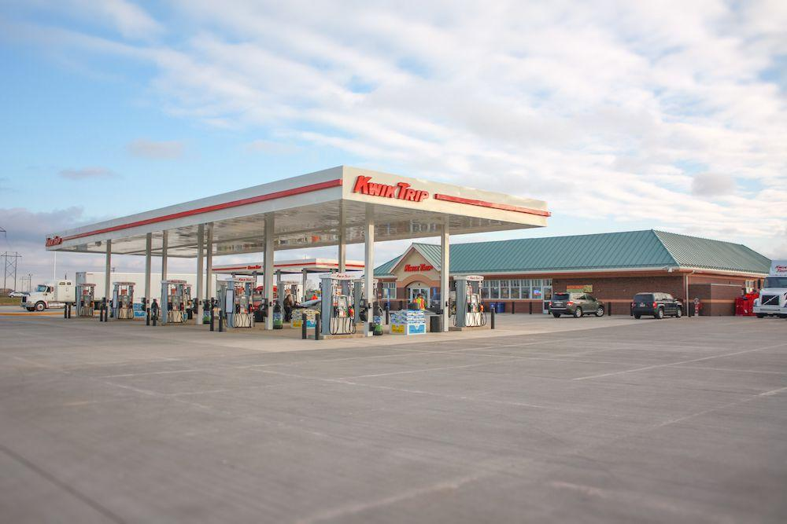

Operations Management
Instructor Michael McArdle
Shannan Rowan
April 3rd, 2023

Table Of Contents

Introduction…………………………………………………………………..………..2

Location………………………………………………………………………..………2-4

Facility Layout………………………….………………………………………..……4-5

Capacity………………………………………………………………………..………5-7

How Do These Interrelate………………………………………………………………………..…….7-8

Summary……………………………………………………………………………….8-9

Appendix……………………………………………………………………………….10

Works Cited…………………………………………………………………………….11-12.

Introduction
There is a saying amongst the Upper Midwest, “Go to any town in Wisconsin, and there will be a Kwik Trip.” While a bit exaggerating, it has become fact that there is a considerable number of these convenience stores to be found in the Upper Midwest. This, however, is done by design, as Kwik Trip has a strategy in selecting certain locations based on how best to serve the community it is entering. These locations are not all the same, as many of the locations are selected and then built according to the demand of the market. For example, in Tomah, Wisconsin there is a location at the south end of the town which services Highway 16 customers. But on the north side of the town, there is a Kwik Trip location that is a diesel truck stop, servicing those coming off the interstate. However, exactly one block to the west of these locations is another Kwik Trip store, set to service the customers headed towards Fort McCoy on Highway 21. This example signifies how Kwik Trip understands and uses locations not just to establish another store, but to help service the customers of the market they are targeting. Today, this report will discuss on how Kwik Trip selects locations, how these facilities are laid out, how capacity is managed on how many items to put out and when, and how all these factors contribute to customer satisfaction and rate of sales that directly lead to its success.
Location
To begin, Kwik Trip uses quite a bit of strategy when selecting a location to have a store. This is exceptionally important because where Kwik Trip decides to place locations contributes directly to its success and customer satisfaction before they even must purchase any of the products. So, by having locations placed right on major highways, corner lots, and next to roundabouts are just some of the most common locations that commuters can easily stop by before continuing their journey. According to an article written by Entrepreneur, the best location for a brick-and-mortar retail businesses combines visibility, affordability, and acceptable leasing terms. (Entrepreneur) Having locations next to major roadways and highways provides easy access for Kwik Trips delivery services, which it keeps inhouse. As stated in the provided textbook Introduction to Supply Chain and Operations Management – A Real World Perspective by Joseph Walden the other factors that go into location selection are culture, quality of life, transportation networks and local or regional regulations. (Walden, pg. 202-204) This means that just because a location near an intersection is a good idea, it might not work if additional work needs to be done to the area. If customers cannot access the location they will be unwilling to return, so location stability must also be considered. There are also legal issues that must be addressed as well, considering that Kwik Trip provides gasoline, a dangerous chemical, there are rules and regulations that must be followed to ensure safety for all parties. According to an article written by John Lofstock “The Federal Energy Regulatory Commission (FERC) is the primary regulator of oil and gas companies, but other organizations oversee specific aspects of the industry,” (Lofstock) Commissions such as these would need to be involved with companies such as Kwik Trip to ensure the safe transportation and distribution of gas, considering Kwik Trip owns its own supply line of gas. There are also multiple driveways for customers to enter and exit, and if the location provides diesel for semi drivers, there are specific driveways for them to enter that are separate from the normal car areas. In an article written by Britney Brown for Dor Magazine “Convenience stores thrive on business from people who need a fast solution and easy purchase access, which is why customers tend to frequent convenience stores along their commuting route.” (Brown) In addition to smart business strategies, placing store locations in these areas circle back to customer service but it’s before the customer even leaves the car to purchase. But then once the customer exits the vehicle, they find themselves in the middle of the layout of the facility, easily able to access the storefront.
Facility Layout
Because Kwik Trip mainly supplies gasoline, the facility layout does include the gas pump area, as customers are able to make purchases out at the pumps themselves and employees work in this area as well. As shown in Appendix A, the gas pumps are the first thing a customer would see pulling into the location, so they are given the option to pull up to a pump or pull to a parking space which is located close to the storefront. (Appendix A) This provides convenience for the customer so they may not have to walk long distances or through the gas pump, which could increase the risk of being hit by a car or knocking a pump loose. Then, the customer enters the storefront, usually through a set of double doors. According to Per Mar Security, “In addition to robust security and bulletproof glass, it’s important to also have usually one point of entrance for all customers and employees.” (Marr) While there is a delivery dock to the side, most Kwik trips will provide one entrance for customers to enter and exit, unless the location supplies diesel, then it could possibly have one more entrance, however these are going to be located right by the checkout area just like the other set of doors, making it so employees have as many eyes on customers as possible. When inside, there are displays near the checkout that help to prevent bottlenecks and guide traffic so customers can wait in line while other customers are just coming into the building. According to the provided textbook Introduction to Supply Chain and Operations Management – A Real World Perspective by Joseph Walden, page 172 paragraph 1, one of the main goals of having displays in the middle of the sales floor prevents bottlenecks. (Walden) This layout is a mix of process and product as there is a maze effect that the customers must walk through to get to the checkout area that helps to keep even lines. Also, the displays have the products on them, such as bakery products and any other on sale items, this entices the customers who are waiting in line to buy more than what they have already selected. With the implementation of strictly prepaying at the pump or coming inside, having a layout is more important than ever for Kwik Trip. According to an article written by Jackson Lewis, quoting David Niemi, a spokesperson for Kwik Trip “Our co-workers spend so much time watching the fuel islands for drive-offs, they can’t focus solely on the guests in the stores.” (Lewis) By increasing the waiting area, having more registers open, and providing displays to help direct foot traffic, Kwik Trip makes their checkout areas more streamlined to service the customers in a quicker manner. All this ties into Kwik Trips’ overall outlook on their culture, which is treating their employees and guests like family. Due to this policy change and the viral popularity the company has garnered as of late, Kwik Trips facility layout leads to it being able to handle overall capacity needs and demands.
Capacity
The Merriam-Webster dictionary defines capacity in the context of business as “the facility or power to produce, perform, or deploy.” (Webster) So, when one thinks of capacity, instead of how many people it would take to fill up a certain location, the context in which capacity will be utilized for this report will be how many items would need to be made over a certain period to meet a certain amount of projected demand.
Kwik Trip is famously known for its hot bar items; however, these items can be costly to make if not planned and handled carefully. Due to the popularity of these items, thanks to the endless number of posts made on social media regarding the food, there are times when the stores will experience an increase in demand and therefore must increase supply to keep capacity on their hot bar items. In an article written by Anita Rajasekaran, they write that those businesses, especially convenience stores, hinge on a careful balance of demand and supply. (Rajasekaran) Also, this a health issue too, for According to the FDA, any food considered perishable can only be left out at room temperature for more than two hours. Keeping food in the hot bar can be effective for freshness, but also the FDA states that any food held in ninety degrees or more can only be held safe for one hour instead of just two. (FDA) For Kwik Trip, this means that capacity utilization of the hot bar area is paramount because it needs to delicately balance having product that’s fresh, making sure not too much is being tossed out thus costing money, and ensuring that there is always product on the shelf. While one could not attain the current capacity utilization rate for a given location, instead there was research into what a good utilization rate looks like. While there is always a viewpoint that 100% is best, according to the provided textbook, Introduction to Supply Chain and Operations Management – A Real World Perspective, on page 166, the argument does get made about how operating at 100% is not just a waste of one’s raw material but also could result in a waste of precious inventory in general. (Walden) However, that also does not necessarily mean one wants an extremely low percentage rate either, as according to an article written by Craig, Keolanui, the lower percentage rate of 50% to 70% means under capacity utilization, which means there are significant problems if the capacity rate hits that number. (Keolanui) This would then place the ideal capacity utilization rate at around 80-85%, with any above that starting to hit the over utilization rate and the under starting to hit the underutilization. Thus, this provides us with proof that capacity and capacity utilization rates are a delicate balancing acts that can have terrible consequences if that balance is lost. Kwik Trip works to maintain this balance by ensuring that there is always a demand for their product. Not just with strong social media campaigns but also by providing fresh new products that intrigue customers. If there was one area that requires constant improvement and innovation because of the increase in demand of the new products and the classics, Kwik Trips hot bar would be the best selection, showing that the company is already conscious of the strategy of progress to remain competitive.
How Do These Area Interrelate?
Location, facility layout and capacity planning all have a common theme, planning for the customers that come in and how best to service them in the timeliest of manners. While most would consider products and service to be a more important aspect of customer service and making sure they have things to purchase, customers will never enter the door if they cannot find the door or if that door is someplace an establishment in that market wouldn’t typically be located. According to the book Operations Management and Management Science by Nneoma Benita Amos and Edafe Bawa Dogo, “Facility Location is an important factor in the supply chain that significantly impacts on the efficiency and effectiveness of many supply networks and the organization at large.” (Amos) This means that for Kwik Trip, who own most of their supply chains including delivery, they have complete control over the locations selected to have stores at based on proximity to distribution centers and target markets. They also have complete control over their facility layouts, only having to stay within state and federal regulations. These reasons are also some of the same reasons Kwik Trip has been slow to expand nationally, remaining primarily in the Upper Midwest region. Their commitment to freshness and maintaining ownership over their supply chains make expanding outwards to stores further away more difficult because the freshness of the product cannot be guaranteed. All these also tie into Kwik Trips’ overall strategy of being the convenience store on “every block” but also having the right amount of product, the right amount of parking spaces and the right area for customers to safely drive in and out of.
Summary
In conclusion, convenience stores generally always have had a stereotypical reputation for providing gas, but always subpar food that made one regret the decision to purchase a couple hours later. While not unfounded, therein lies a golden opportunity that Kwik Trip has grasped firmly and not let go of. By providing not just gas that some locals will swear is better than any other gas one could get elsewhere, but also providing hot food that is made at just the right time to be grabbed by eager customers, Kwik Trip has unlocked a serious strategy that is paying off for the company. The customer experience starts just as one pulls into the location, making the very first decision of where to place a store location paramount, then where the customer can park and get their gas or to enter the establishment, and finally ensuring that there is enough for the customers that enter to be able to purchase and leave, all while being subliminally guided with displays and different areas. All this needs to flow together and be maintained if a company wants to expand but also keep standards high, for the same care in location selection, layout and capacity must be considered before being able to order or make a single product.

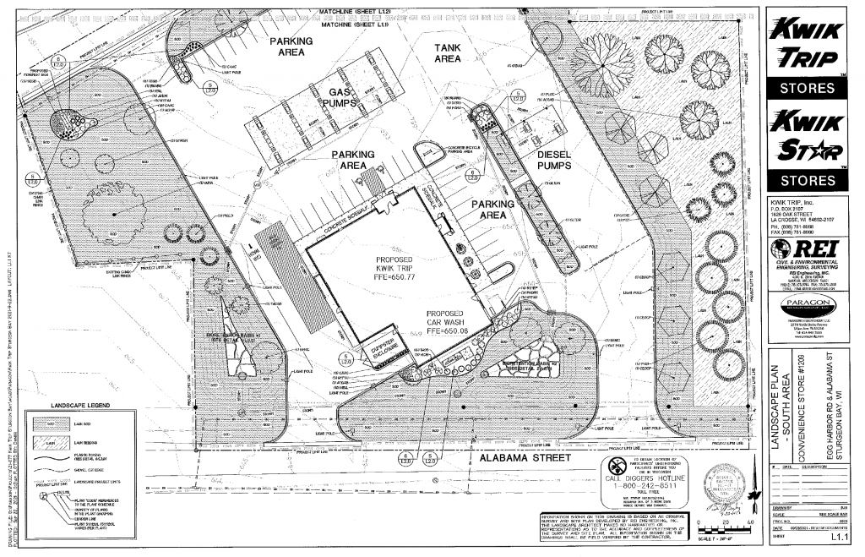
Appendix A

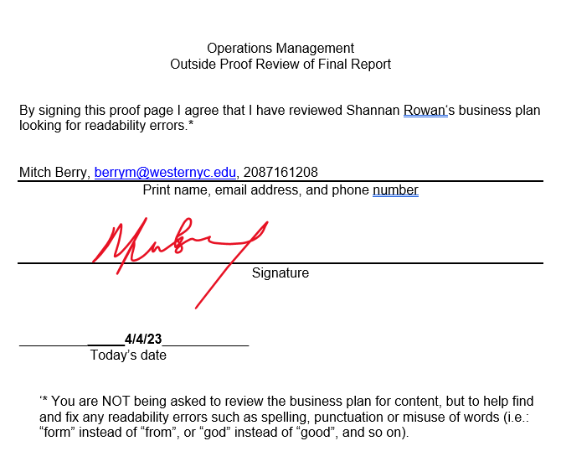
Works Cited
Amos, Nneoma Benita, and Edafe Bawa Dogo. “Facility Location.” IntechOpen, IntechOpen, 7 Sept. 2022, www.intechopen.com/chapters/1083439.
Brown, Britney. “7 Factors That Affect Foot Traffic for Retailers.” Foot Traffic and People Counting for Retail & Facilities - Dor Blog, Foot Traffic and People Counting for Retail & Facilities - Dor Blog, 9 Apr. 2020, www.getdor.com/blog/2019/12/05/factors-affect-foot-traffic/.
Lewis, Jackson. “Kwik Trip Moves to Pre-Pay Only at Pump.” CSP Daily News, CSP Daily News, 3 Dec. 2021, www.cspdailynews.com/fuels/kwik-trip-moves-pre-pay-only-pump.
Lofstock, John. “How to Choose a Location for Your next Convenience Store or Gas Station.” CStore Decisions, 15 Nov. 2022, cstoredecisions.com/2022/11/14/how-to-choose-a-location-for-your-gas-station/.
Marr, Per. “Convenience Store Security Checklist.” Per Mar Security Services, 23 June 2022, permarsecurity.com/convenience-store-security-checklist/.
The Staff of Entrepreneur Media, Inc. “How to Find the Right Location for Your Store.” Entrepreneur, Entrepreneur, 1 June 2015, www.entrepreneur.com/starting-a-business/how-to-find-the-right-location-for-your-store/246322.
Walden, Joseph Phd. “Introduction to Supply Chain and Operations Management – A Real World Perspective.” KU ScholarWorks, 4 Sept. 2020, kuscholarworks.ku.edu/handle/1808/30723.
Webster, Merriam. “Capacity Definition & Meaning.” Merriam-Webster, Merriam-Webster, 2023, www.merriam-webster.com/dictionary/capacity.

